

**Final Year Project**

|  |  |
| --- | --- |
| **Assignment Deadline:** | **28/4/2023** |
| **Module Code:** | **ENX313** |
| **Module Title:** | **Regenerative Braking System** |
| **Module Leader:** | **Aidan Bowes** |
| **Student Name:** | **Meng Heng Chong** |
| **Student Number:** | **229145757** |
| **Degree Programme Title:** | **BEng in Mechanical Engineering** |
| **Academic Year:** | **2022/23** |

**DECLARATION**

I, Meng Heng Chong sincerely declare that this project report “**Regenerative Braking System**” is the result of my own work. Those do not result of my own work had been clearly cited in the reference list.

Signature :

Name : Meng Heng Chong

ID Number : 229145757

Date : 28/4/2023

**Abstract**

Regenerative braking is an energy recovery mechanism that generates electricity from the kinetic energy of a moving vehicle during braking. In this project, a prototype of a regenerative braking system is designed and fabricated. The main concept of the prototype is to use the rotational force of the transmission system to turn the generator, thereby generating electricity. The project includes a literature review of working principles and technologies in conventional braking and different types of regenerative braking, followed by the design and fabrication of the prototype system. During the research, it is found that regenerative braking is only suitable for the situation where the transmission system is gradually slowing down and coming to a complete stop. It has insufficient braking power to stop the transmission immediately if there is a dangerous situation, thus conventional braking is still necessary for safety purposes. In this prototype, the regenerative braking system is assisted by conventional braking. The main component in the regenerative braking part of this prototype is an electric motor that functions as a generator, gears that are used for energy transmission from the transmission system to the generator, a battery to store the electricity generated during regenerative braking, and a charging circuit to regulate the flow of electric current to the battery. Once the prototype is built, testing is designed and conducted to test the performance in terms of energy efficiency, charging ability, and braking performance. The result of testing is then discussed and analysed, it shows that the regenerative braking system is able to generate electricity during braking, able to slow down the transmission system gradually, and able to store the electricity generated during regenerative braking for later use. At the end of the project, several recommendations for the prototype have been discussed such as the development of the motor controlling system and the braking control system.

**ACKNOWLEDGEMENTS**

I would like to take this opportunity to gratitude my supervisor, Mr Aidan Bowes in guiding me to complete my project. His patience and invaluable advice which had given to me throughout this project had helped me a lot in completing my project.

Finally, I would like to express my appreciation to Mr David Winter and Mr Chris who had given me full support when I faced problems. Without their support, I might not be able to complete my project successfully.

Thank You

Meng Heng Chong

APRIL 2023

TABLE CONTENTS

1. Introduction
   1. Introduction 1
   2. Aim 2
   3. Objective 2
2. Literature Review
   1. History of Regenerative Braking System 3
   2. Conventional Braking 4-5
   3. Regenerative Braking
      1. Electric regenerative braking system 6-7
      2. Hydraulic regenerative braking system 8-9
      3. Flywheel-based regenerative braking system 10-11
   4. Why regenerative braking is assisted by conventional braking 12
   5. Comparison between regenerative braking and conventional braking 12
   6. Summary & critical appraisal 13-14
3. Methodology
   1. Design Process Map 15-16
   2. Functional block 17-18
   3. Work breakdown structure 19
   4. Gantt chart 20
   5. Design of regenerative braking system
      1. Design of solid shaft 21
      2. Design of brake gear 22
      3. Design of brake rotor 23
      4. Design of coupling 23
      5. Design of motor side board 24
      6. Design of another side board 24
      7. Design of syringe support 25
      8. Design of triangular support 25
      9. Design of brake pedal assembly 26
      10. Design of disc brake 27
      11. Design of syringe 27
      12. Design of generator 28
      13. Design of motor 28
      14. Design of rechargeable battery 29
      15. Design of breadboard 29
      16. Circuit design of regenerative braking 30
   6. Assembly drawing of prototype 31-32
   7. Equipment & tools used in the fabrication of the prototype 33-35
   8. Fabrication of main parts of the prototype
      1. Fabrication of solid shaft 36
      2. Fabrication of brake rotor 37
      3. Fabrication of brake gear 37
      4. Fabrication of coupling 38
      5. Fabrication of motor sideboard 39
      6. Fabrication of sideboard 39
      7. Fabrication of syringe support 40
      8. Disc brake 40
      9. Motor coupling 41
      10. Rechargeable battery 41
      11. Generator 42
      12. Syringe 42
   9. List of parts used in fabrication 43
   10. Construction of prototype 44-46
   11. Operation of prototype 47
   12. Testing of prototype 48

4.0 Results & Discussion

4.1 Results 49-50

4.2 Discussion 51-52

5.0 Conclusion & Further Work

5.1 Conclusion 53-54

5.2 Further work 54

6.0 Reference 55-56

7.0 Appendix 57-60

Chapter 1 Introduction

1.1 Introduction

In recent years, electric vehicles are widely established in the automobile markets they offer several huge advantages such as zero carbon emission, low noise pollution, lower operating cost, and government incentive. However, the major weakness of electric vehicle against fuel vehicle is that it has shorter traveling distance per refill and is not suitable for long distance travel (EnergySage, 2023). In this project, the design and fabrication of regenerative braking system is developed, with the aim of recovering and he kinetic energy that is normally wasted during braking, thus reducing the overall energy consumption of the vehicle.

Regenerative braking is an important technology for electric or hybrid vehicles because it allows vehicles to recover energy that would otherwise be lost during braking, and use that energy to improve the efficiency of the vehicle. When a vehicle uses conventional brakes, the kinetic energy of the moving vehicle is converted into heat energy, which is dissipated into the environment. This represents a significant waste of energy, particularly in stop-and-go driving conditions where frequent braking is required. Regenerative braking, on the other hand, uses an electric motor to slow the vehicle down and convert the kinetic energy of the moving vehicle into electrical energy, which is then stored in a battery or used to power the vehicle's electrical systems. This allows the vehicle to reuse some of the energy that would otherwise be lost during braking, improving the overall efficiency of the vehicle.

In addition to improving efficiency, regenerative braking can also help to extend the range of electric vehicles by providing additional energy to the vehicle's battery. It can also reduce wear and tear on conventional brakes, resulting in lower maintenance costs over the life of the vehicle. Hence, regenerative braking is an important technology that can help to improve the efficiency and sustainability of vehicles, particularly in urban driving conditions where frequent braking is required. In this report, the design and fabrication of a prototype of a regenerative braking system will be presented.

The idea of regenerative braking systems is not new, and it has been implemented in various forms in hybrid and electric vehicles. However, there is still a need for more research and development in this area to make regenerative braking systems more efficient, cost-effective, and widely adopted. What makes this project different is that it makes regenerative braking systems more accessible and affordable for a wider range of vehicles. This could lead to a significant reduction in energy consumption and environmental impact, contributing to a more sustainable and efficient transportation system.

1.2 Aim

The aim of a regenerative braking project is to develop a prototype of the regenerative braking system, with the goal of improving energy efficiency, thereby extending the vehicle's range. Regenerative braking projects involve the design, fabrication, and testing of the regenerative braking system. Besides that, the aim of this project is to integrate the regenerative braking system with the vehicle's existing braking system and ensure that it is compatible with other vehicle systems. This project aims to capture the kinetic energy that is normally lost during braking and convert it into electrical energy that can be stored for later use.

1.3 Objectives

* To develop a prototype which able to convert kinetic energy to electrical energy when braking the transmission system.
* To develop a prototype that is able to reduce the speed of the transmission system when the brake is applied.
* To develop a prototype that is able to store the electricity generated during regenerative braking.
* To develop a regenerative braking system that is safe in varies driving situation.

Chapter 2 Literature Review

2.1 History of regenerative braking

In 1886, the Sprague Electric Railway & Motor Company introduced regenerative braking. Early application of regenerative braking in road vehicles were front-wheel drive conversions of horse-drawn cabs by Louis Antoine Krieger in Paris in the 1890s. The Krieger electric landaulet had a drive motor in each front wheel with a second set of parallel windings for regenerative braking. The Orwell Electric Truck introduced during World War 1 used regenerative braking switched in by driver. Regenerative braking was also used on railways such as the Transcaucasia Railway and those in Scandinavia in the 1930s (Treehugger, 2021).In 1967, the American Motor Car Company (AMC) created an electrical energy regeneration brake for their concept electric car, the AMC Amitron (Treehugger, 2021). It can travel for impressive range of 150 miles and regenerative braking (Treehugger, 2021). Regenerative braking technology was later adapted for use in electric and hybrid vehicles. In 1997, Toyota become the first car manufacturer to commercialize RBS technology in their Prius series hybrid cars (Energy Education, 2022). The Prius used a system called electronically controlled brake (ECB), which combined regenerative braking with conventional hydraulic braking.

In 21st century, regenerative braking has become a standard future in most electric and hybrid vehicles. It is also used in other application such as trains, elevators and industrial equipment. Regenerative braking widely known to be an effective way to reduce energy consumption, reduce emission and improve efficiency in a variety of industries. Today, Japan's highly efficient maglev trains and France's TGVs use regenerative braking, as do most electric trains and metro systems all around the world. Increasingly popular electric bicycles (e-bikes), scooters, and skateboards also use regenerative braking, with an efficiency of some 4% to 5%. (Treehugger, 2021)

2.2 Conventional braking

Conventional braking refers to the frictional brake, which is the most common braking system used in internal combustion engines. It uses friction to slow down or stop the vehicle, and converts the kinetic energy of the vehicle to heat energy. The most common type of conventional braking is the disc brake.

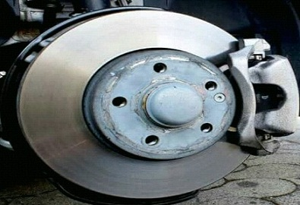

Figure 2.1 Structure of disc brake (Handyman tips, 2020)

Disc brake has replaced drum brake and become the most common frictional brake for vehicles. By observing the car’s front wheels, we can see a shiny metal disc inside, and it is called a disc brake. A disc brake is usually made of cast iron, but there is a high-end disc brake that is made of carbon or ceramic composites. The disc brake is linked to the wheel or axle. It consists of brake pads made of high-friction material, so that there is enough friction to slow down or stop the vehicle.

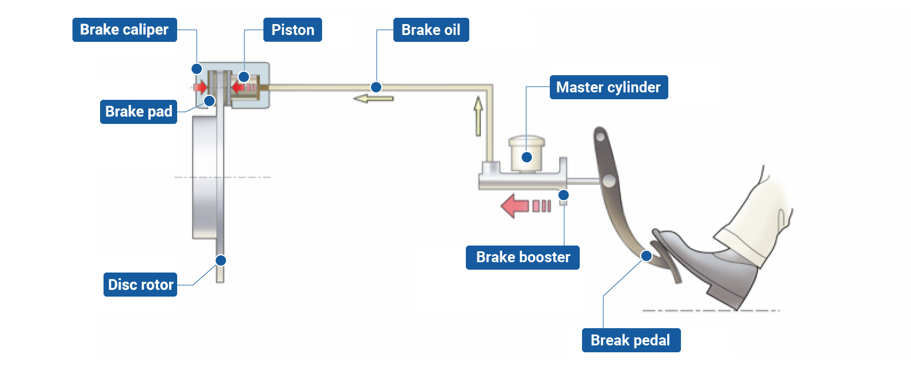

Figure 2.2 Working of disc brake (AKEBONO BRAKE INDUSTRY CO., LTD., 2023)

The main element of the disc brake systemthe is brake pad, hydraulic system, brake pedal, brake callipers, and rotor. Through this process, the kinetic energy of the vehicle is converted to heat energy, which is wasted. When the driver presses the brake pedal, the brake booster (servo system) amplifies the force and the master cylinder converts it into hydraulic pressure (oil pressure). Through tubing containing brake oil (brake fluid), pressure is delivered to the brakes on the wheels. The pistons on the four-wheel brakes are pushed by the pressure that is applied. The brake rotors always rotate with the wheels, and the pistons in turn force the frictional brake pads against them. The brake pads slow down and stop the car by clamping on the rotors from both sides and decelerating the wheels.Top of Form

(AKEBONO BRAKE INDUSTRY CO., LTD., 2023).

One of the main advantages of conventional braking is that it is a simple and reliable system that is relatively easy to maintain and repair. The parts used in conventional braking systems are widely available and relatively inexpensive, making them an affordable option for many vehicle owners.

However, conventional braking systems also have some disadvantages. They are less efficient than regenerative braking systems, which can recover some of the energy lost during braking and convert it into electrical energy to recharge the vehicle's battery. Conventional braking systems also create heat and wear on the brake pads and rotors, which can reduce their lifespan and require more frequent maintenance and replacement.

2.3 Regenerative Braking System

Regenerative braking is a technology used in electric vehicles and hybrid electric vehicles. It is a sort of energy recovery that reduces the speed of a moving vehicle or object by transforming its kinetic energy into electric energy that may either be used right away or stored for later use, which in turns reducing the need to draw energy from the battery or engine, thus extending the vehicle range. There are several types of regenerative braking system, which is electric regenerative braking system, hydraulic regenerative braking system, and flywheel-based regenerative braking system.

2.3.1 Electric regenerative braking system

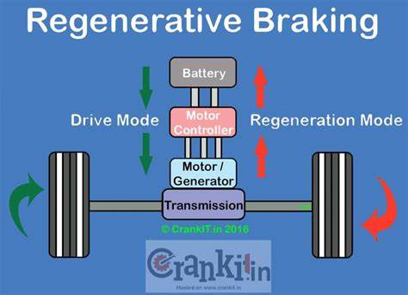

Figure 2.3 Structure of electric regenerative braking system

Electric regenerative braking system consists of a motor/generator unit, motor controller, and batteries. The motor/generator unit works as a motor in one direction and a generator in the opposite direction. When it runs as a motor, it converts the electrical energy into mechanical energy which drives the wheel (CarBikeTech, 2020). The electric traction motor in this system uses the vehicle’s momentum to recover energy. When the driver applies the brakes, the motor acts as an electric generator, producing electricity and then fed into the battery, which can be used to accelerate the vehicle again when it stops (HowStuffWorks, 2009).

As the car accelerates, the motor/generator unit functions as an electric motor, taking power from the batteries to provide additional driving force. The internal combustion engine of the car, which is smaller and has a lower peak output, can achieve great efficiency with the assistance of the motor. When the brake is applied, the motor controller controls the charge flowing through the motor by providing electric resistance, depending on how hard the driver presses the brake pedal. When the electric resistance offered is high and no current flowing to the motor, it rotates back to act as a generator. The energy generated is stored in a battery or bank of twin layer capacitors for later use. The motor/generator unit serves as an electric generator while the automobile is still going forward after braking occurred, transforming kinetic energy into electrical and storing it in the batteries for later use. (Mechanical Farm, 2021)

Regenerative braking is not by itself sufficient as the sole means of safely bringing a vehicle to a standstill, or slowing it as required, so it must be used in conjunction with another braking system such as friction-based braking. (Wikipedia, 2023)

The electric regenerative braking system offers several benefits. It increases the energy efficiency by converting the energy generated during braking into electricity, regenerative braking system can help to increase the overall efficiency of electric vehicles and hybrid electric vehicles. Besides that, regenerative braking system help to extend the range of electric vehicles and hybrid vehicles by storing the energy generated during braking (ConnectUS, 2018). Furthermore, regenerative braking system provide a smoother and more gradual braking experience, as the vehicle decelerates more gradually than with traditional brakes. As an addition, regenerative braking system can reduce the wear and tear on the mechanical brakes, as electric traction is used more frequently to stop the vehicles (OnAllCylinders, 2021).

2.3.2 Hydraulic regenerative braking system

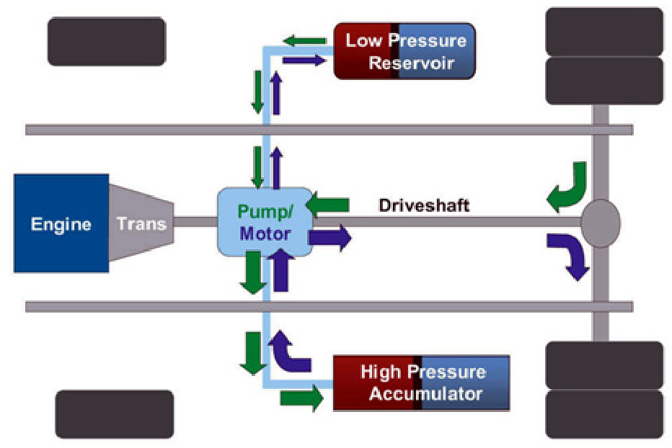

Figure 2.4 Structure of hydraulic regenerative braking system

Hydrostatic Regenerative Braking System (HRBS) is a type of regenerative braking system that uses hydraulic fluid to store energy generated during braking. HRBS is commonly used in heavy-duty vehicles such as buses, trucks, and construction equipment.

In HRBS, the hydraulic system consists of a hydraulic pump/motor, a hydraulic accumulator, and a control valve. During braking, the kinetic energy of vehicles is used to power the reversible pump, it pumps the hydraulic fluid from the low-pressure accumulator (a kind of storage tank) inside the vehicle into a high-pressure accumulator. The pressure is created by nitrogen gas in the accumulator, which is compressed as the fluid is pumped into the space the gas formerly occupied. This slows the vehicle and helps bring it to a stop. As a result, the kinetic energy of the vehicle is converted into hydraulic pressure. The fluid remains under pressure in the accumulator until the driver pushes the accelerator again, at which point the pump is reversed and the pressurized fluid is used to accelerate the vehicle, effectively translating the kinetic energy that the car had before braking into the mechanical energy that helps get the vehicle back up to speed. Besides that, the stored energy can also be used to assist in vehicle power auxiliary systems, such as air conditioning or power steering. The control valve and electronic controller regulates the flow of hydraulic fluid and controls the amount of energy stored in the accumulator. The hydraulic pump/motor provides additional power to the vehicle during acceleration, reducing the load on the engine and improving fuel efficiency. (Mechanical Farm, 2021)

HRBS has several advantages over other types of regenerative braking systems. It is particularly effective in heavy-duty vehicles, where the energy generated during braking is significant. HRBS also has a faster response time compared to electric regenerative braking systems, making it particularly useful in stop-and-go traffic situations. (Mechanical Farm, 2021)

However, HRBS has some disadvantages as well. It is more complex than other types of regenerative braking systems, which can lead to higher maintenance costs. It also requires specialized hydraulic components, which can be expensive. At present, these hydraulic regenerative brakes are noisy and prone to leaks; however, once all of the details are ironed out, such systems will probably be most useful in large trucks. (Mechanical Farm, 2021)

2.3.3 Flywheel-Based regenerative braking system

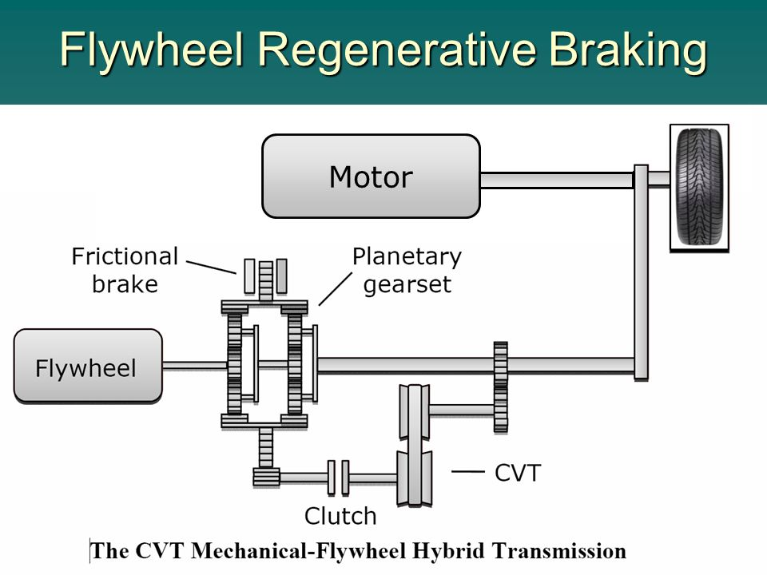

Figure 2.5 Structure of flywheel regenerative braking system

([PDF] REGENERATIVE BRAKING SYSTEMS (RBS): Semantic Scholar, 2021)

Flywheel-based regenerative braking system consist a wheel with an extremely heavy metal rim attached on the drive shaft. The flywheel is used to store rotational energy that is wasted during braking operation.

When the vehicle is accelerating, the flywheel is disengaged from the transmission system. When the vehicle is braking, the flywheel is engaged with the transmission system, absorb some of the kinetic energy and bring vehicle to halt. When the vehicle started off later, the rotating flywheel return the energy and turns the vehicle before it disengaged from the transmission system during normal driving. (Mechanical Farm, 2021)

The transfer of energy in both directions (captured from the driveline during coasting and braking, and released to the driveline for boost) is managed through a CVT (Continuously Variable Transmission) gear box. Packaged inside a single housing is a shaft mounted flywheel that is connected via a chain/gear or belt/pulley drive to a series of discs and rollers (the CVT). During braking and coasting, the flywheel spools-up (accelerates as it spins) and absorbs a storehouse of otherwise wasted energy (heat from friction brakes). During power delivery, as the vehicle begins to accelerate, the pent-up energy in the flywheel is released and it turns the shaft. The rollers within the CVT can change position across the discs and either retard or augment the torque of the spinning flywheel shaft much like a conventional step-up or step-down gear box. This “gearing” is necessary, because unlike aircraft, and to a certain extent watercraft, which travel at a relatively constant load and speed, earth-bound vehicles travel at regularly and greatly varying speeds and loads as they negotiate traffic and topography. It is this variable output velocity that allows for smooth power transmission from the flywheel to the driveline as the vehicle travels over the roadway. (Mechanical Farm, 2021)

The disadvantage of flywheel-based regenerative braking system is that it contributes extra weight to the vehicle and costs extra energy because vehicle have to carry them all the time. (Mechanical Farm, 2021)

2.4 The reason of regenerative braking system must be assisted by frictional brake

Regenerative braking must be used in conjunction with frictional brake because the regenerative braking is less effective to bring the vehicle to a complete stop immediately, so the frictional brake is still required for safety purposes. It is also a necessary backup if the regenerative brake fails.

Besides that, the majority of road vehicles with regenerative braking only have regenerative brakes on some wheels such as 2-wheel drive cars, and regenerative braking power only applies to such wheels, so friction-based braking is required on the other wheels to provide controlled braking in challenging circumstances such as driving on a wet road or driving down the hill. (Mechanical Farm, 2021)

2.5 Comparison between regenerative braking and conventional braking

The advantage of regenerative braking is that it makes the brake pad last longer, since regenerative braking provides huge amount of stopping force, therefore reducing the usage of frictional brake. Besides that, it captures the kinetic energy of the vehicle and convert it into useful electrical energy, rather than useless heat energy converted by frictional brake. Furthermore, it allows vehicle to recover energy that would be otherwise lost during braking, thereby improving the fuel efficiency of the vehicle. ( Tires Plus, 2022)

The disadvantage of regenerative braking is that it is less effective when the vehicle is moving at low speed. Vehicle moving at low speed requires less braking force, regenerative braking fed less energy and does not supply battery pack with much charge. Besides that, regenerative braking provides less braking power than conventional braking. Regenerative braking is only suitable for the braking situations where the vehicle gradually comes to a stop. It is not suitable for the braking situation where the vehicle comes to a stop immediately. ( Tires Plus, 2022)

The advantage of conventional braking is that it provides strong brake power. It is able to slow down the speed of the vehicle drastically. The disadvantage of conventional braking is that the energy is lost during braking. The frictional brake converts kinetic energy into useless heat energy.

2.6 Summary & critical appraisal

Conventional braking, on the other hand, refers to the frictional brake, which is the most common braking system used in internal combustion engines. It uses friction to slow down or stop the vehicle and converts the kinetic energy of the vehicle into heat energy. The most common type of conventional braking is the disc brake, which consists of brake pads made of high-friction material, a hydraulic system, a brake pedal, brake callipers, and a rotor.

The advantages of conventional braking are that it is a simple and reliable system that is relatively easy to maintain and repair, and the parts used in conventional braking systems are widely available and relatively inexpensive. However, conventional braking systems also have some disadvantages. They are less efficient than regenerative braking systems, which can recover some of the energy lost during braking and convert it into electrical energy to recharge the vehicle's battery. Conventional braking systems also create heat and wear on the brake pads and rotors, reducing their lifespan and requiring more frequent maintenance and replacement.

Electric regenerative braking system is one of the types of regenerative braking systems. It consists of a motor/generator unit, motor controller, and batteries. The motor/generator unit works as a motor in one direction and a generator in the opposite direction, converting electrical energy into mechanical energy to drive the wheel. The electric traction motor in this system uses the vehicle’s momentum to recover energy. When the driver applies the brakes, the motor acts as an electric generator, producing electricity.

Hydraulic regenerative braking system is commonly used in heavy vehicles such as trucks and buses. This system uses hydraulic pressure to store the kinetic energy from braking, which is then used to power the vehicle's hydraulic system. In this system, when the driver applies the brakes, the hydraulic pressure in the brake lines is used to compress a gas or hydraulic fluid, which then stores the energy in a high-pressure accumulator (Energy Education, 2022). When the driver accelerates, the energy stored in the accumulator is released to help power the vehicle's hydraulic system.

Flywheel-based regenerative braking system uses a mechanical flywheel to store kinetic energy from braking. When the driver applies the brakes, the kinetic energy is transferred to the flywheel, which spins rapidly and stores the energy as rotational energy. When the driver accelerates, the rotational energy is transferred back to the vehicle's drivetrain (Energy Education, 2022). This system is used in some hybrid buses and is also being explored as a potential option for use in passenger vehicles.

Overall, regenerative braking systems have several advantages over conventional braking systems. They are more energy efficient, which can lead to improved fuel economy and reduced emissions. They also produce less heat and wear on the brake components, which can reduce maintenance and replacement costs. However, regenerative braking systems can be more complex and expensive to manufacture and maintain compared to conventional braking systems.

Regenerative braking is an effective way to reduce energy consumption, reduce emissions, and improve efficiency in a variety of industries. While conventional braking systems are simple and reliable, regenerative braking systems offer significant advantages in terms of energy efficiency and reduced wear and tear on brake components.

The literature review explains the structure and working principles of conventional braking and different types of regenerative braking. The working principle of various regenerative braking provides ideas for the energy recovery mechanism of the prototype. Besides that, the literature review explains the advantages and disadvantages of conventional braking and regenerative braking. It provides an idea for combining the use of conventional braking and regenerative braking in the prototype, thereby maximizing the advantages while minimizing the disadvantages of regenerative braking.

Chapter 3 Methodology

**3.1 Design Process Map**

A good design process map is crucial for every project because it helps people to have a clear concept and procedure to solve current problems. With a design process map, people are able to get required information precisely and have a neat plan which is written step by step clearly. It is a set of steps that a designer takes to go from first, identifying a problem or need to, at the end, creating and developing a solution that solves the problem or meets the need. During the process, it is normal to jump back and forth between the steps as it moves toward the final solution. Going back to earlier steps is common and this way of working is known as iteration. The process map for this project is shown below: (Guide to Process Mapping: Definition, How-to, and Tips [2023] • Asana, 2022)

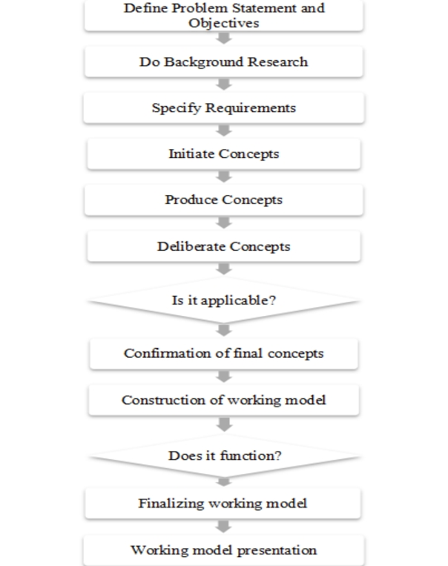

Figure 3.1 Design Process Map

Problem statement is a clear description of the issue that needs to be solved. It helps to provide a clear concept and correct thinking direction for the designer to think about the new design which solves current problems effectively. Once the problem statement has been identified, several objectives are then considered to solve the problem.

Background research is a crucial part of the project because it provides context to the information written in the report, making our study become credible. There are various methods to collect information for background research. All of the research information related to this project is written in the literature review.

Once the background research is done, there will be several specified objectives generated to match the function and further improve the products. This enables the products to have room for improvement and be in line with the best solution.

After visualizing the concept, the concept is categorized into several components that potentially satisfy the product-subfunction. Then, the concept is sketched with a simple label. When a test stand is able to function, the construction of the working model is followed up. Before the construction, write down all the materials, supplies and tools that may need and identify the steps needed to construct the working model. Using the confirmed test stand, one can start the construction. Once the working model is finished, a test should be carried out to ensure it works exactly like the test stand did. If it works, then one can proceed to finalize otherwise, one will need to review and redesign the test stand.

During finalizing, it is better to refer back to the selected concept, from the design, the specification, and the dimension to its operation. Again, test the working model and if any problem occurs, one will have time for troubleshooting and this is the stage where modification of the working model and a little add-on can be done.

Once the working model is built and operates at its satisfying level, it is ready to be presented through the report. Throughout the report, one will have to deliver the discussion of testing results and objectives achievement of the working protype , and explains the operation of the working prototype. At the end of report, recommendation of the prototype is discussed.

3.2 Functional block

Functional block is a block diagram that describes the functions and interrelationship of a system via blocks and diagrams. It consists of a series of simple blocks and diagrams connected by arrows known as "connections" that help to discover the function between output variables and input variables. The divergent-convergent design philosophy is supported by functional decomposition. A design challenge must be stretched into numerous solutions before being narrowed down to one final solution. (Wikipedia, 2023)

The general function of the device is stated in terms of input and output conversions to construct a functional block diagram. This can be done by simply modeling the product or gadget as a box that converts provided inputs into desired outputs. Then, take the main function and split it down into a set of critical subfunctions. It is required to represent the task as a verb plus a noun when identifying subfunctions.

After that, make a block diagram to show how the subfunctions interact. All sub-functions are identified separately in a block diagram by surrounding them in a box. After it is completed, the system boundary is created. The final step is to look for components that are suited for performing each sub-function and its interactions. It's important to find the right component for each subfunction.

Functional blocks below show how the regenerative braking system works. When the force is applied to the syringe, the regenerative braking is triggered, slowing down the vehicle and converting kinetic energy to useful electrical energy. When the force is applied to the brake pedal, the conventional brake is triggered, stopping the vehicle completely and converting kinetic energy to heat energy.

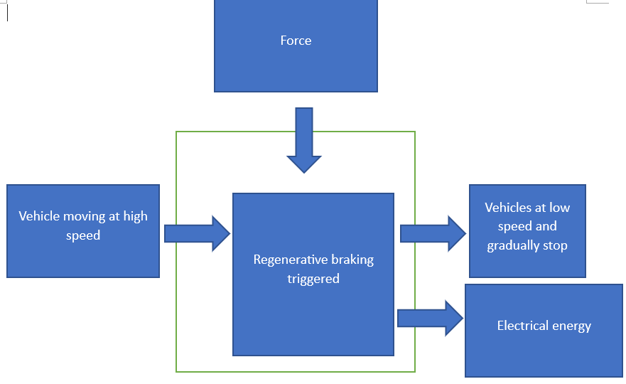

Figure 3.2 Functional block during regenerative braking of prototype

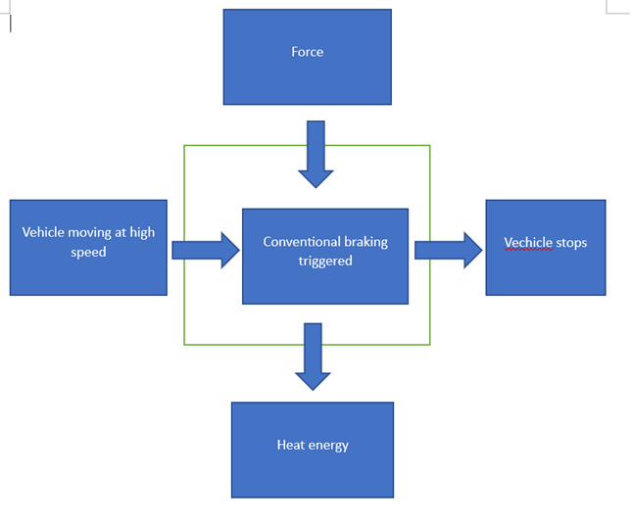

Figure 3.3 Functional block during conventional braking of prototype

3.3 Work breakdown structure

Work breakdown structure is a project management technique which involves decomposition of entire project into individual unit of work. A WBS was created for this project which shows a breakdown of the main tasks involved.

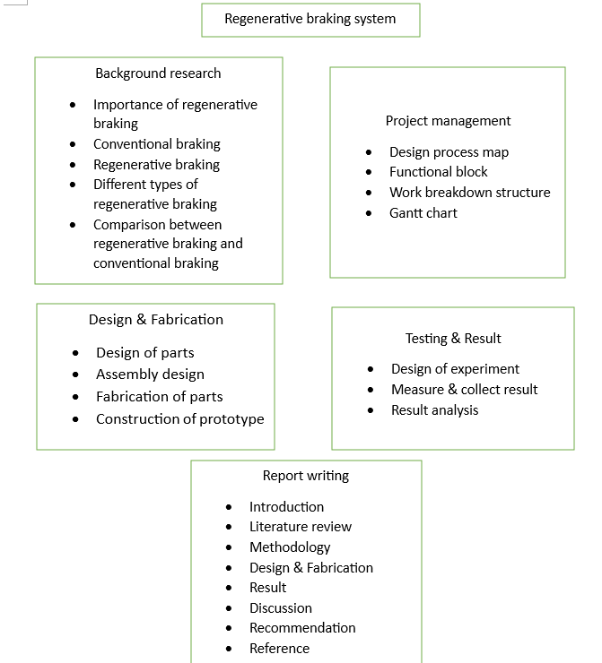

Figure 3.4 Work breakdown structure of this project

3.4 Gantt Chart

It was planned the project would run from week commencing 26/01/22 and be completed by week commencing 22/4/2023, which gives a total of 14 weeks of work. Saturday and Sunday were set as non-working days as it was scheduled that the project would not be worked on during these days. A Gantt chart was produced using Microsoft Project including all tasks from the WBS and their estimated durations.

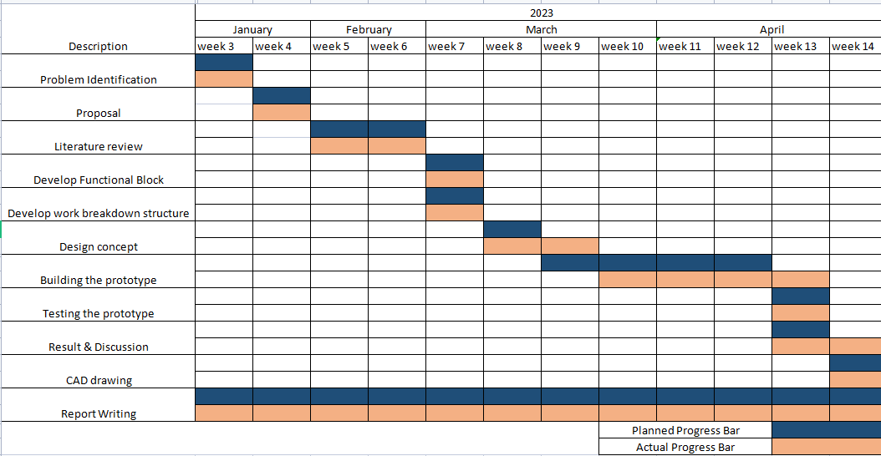

Figure 3.5 Gantt chart of final year project

3.5 Design of Regenerative Braking System

The design of the regenerative braking system was based on the principles of regenerative braking and the components of a regenerative braking system. The system was designed to be efficient, reliable, and compatible with a range of vehicles. The design included the following components. The design was done by using Solidworks 2022.

3.5.1 Design of solid shaft

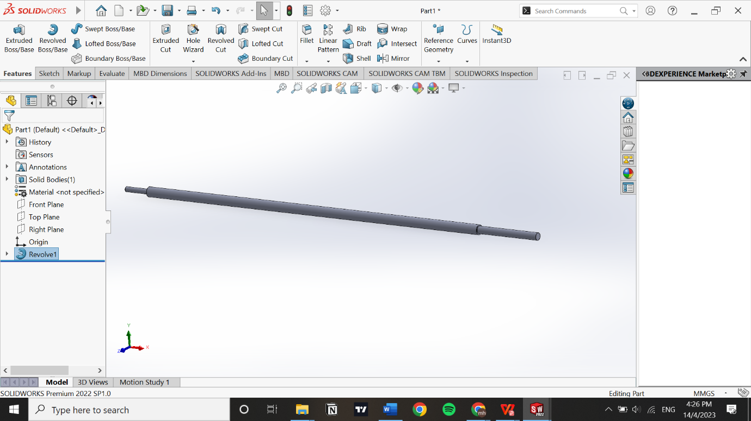

Figure 3.6 Design of solid shaft

The total length of solid shaft is 470mm. The diameter of the middle part of solid shaft is 9.7mm, the end of the solid shaft is 26mm long with 5 mm, and another end of the solid shaft is 67mm long with 7.4 mm diameter.

3.5.2 Design of brake gear

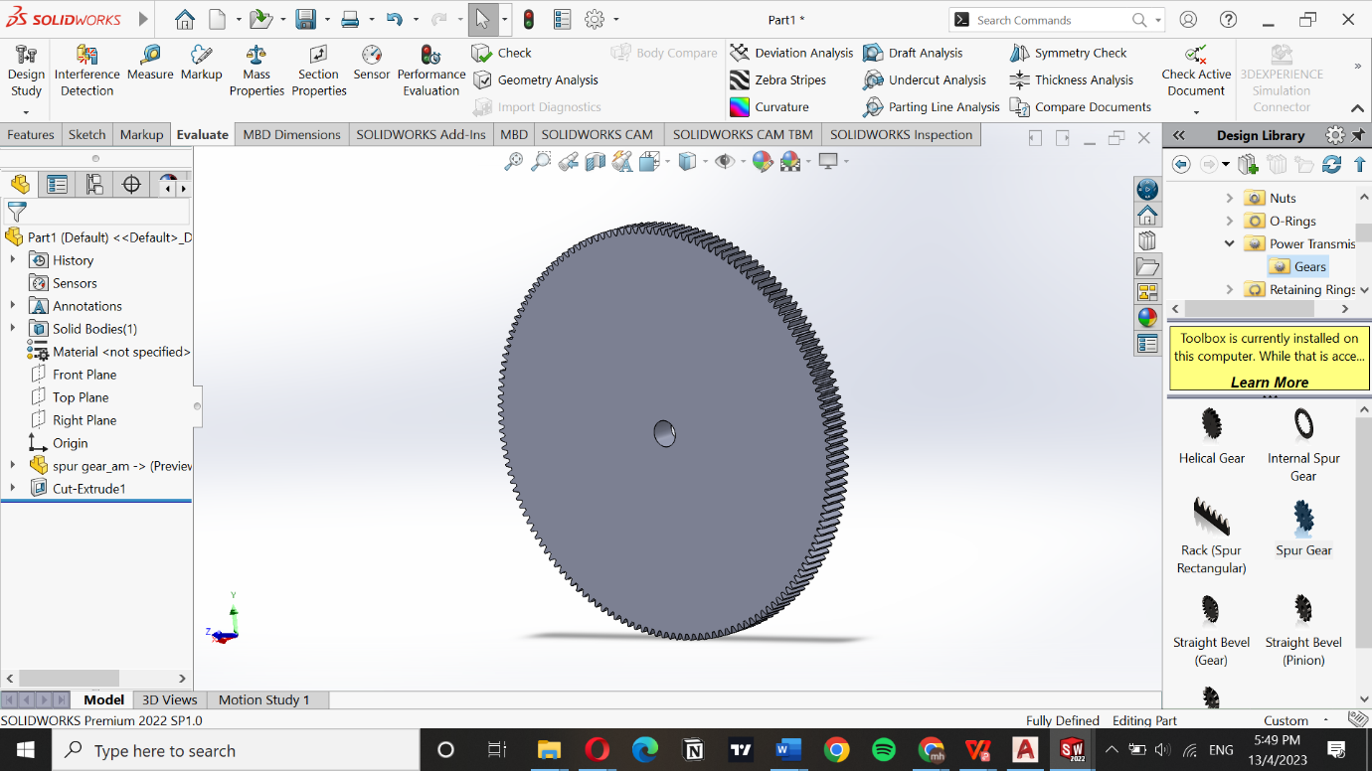

Figure 3.7 Design of brake gear

The brake gear is a spur gear with pitch module of 1, 150 of teeth, 20 degree of pressure angle, 10mm of face width, and 9.7mm of nominal shaft diameter. The pitch module of the brake gear must be the same as that of the gear of the generator so that they can be engaged. The pitch module is calculated by using the formula below.

M=d/z (Blog CLR, 2019)

m= gear module

d= pitch diameter

z= number of teeth

3.5.3 Design of brake rotor

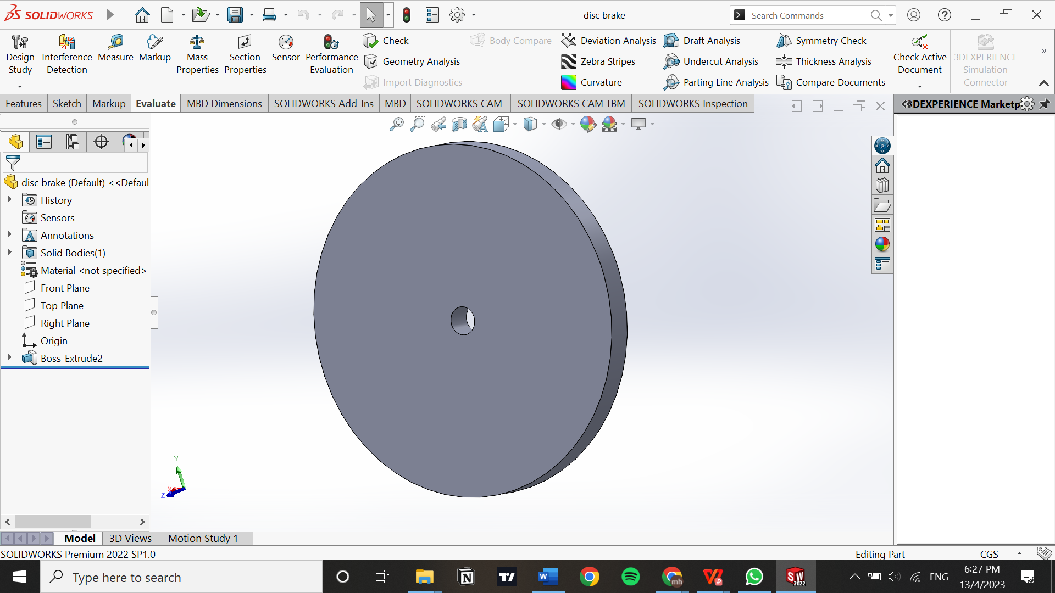

Figure 3.8 Design of brake rotor

The brake rotor is a circular plate with diameter of 10mm, shaft nominal diameter of 9.7mm, and thickness of 5mm.

3.5.4 Design of coupling

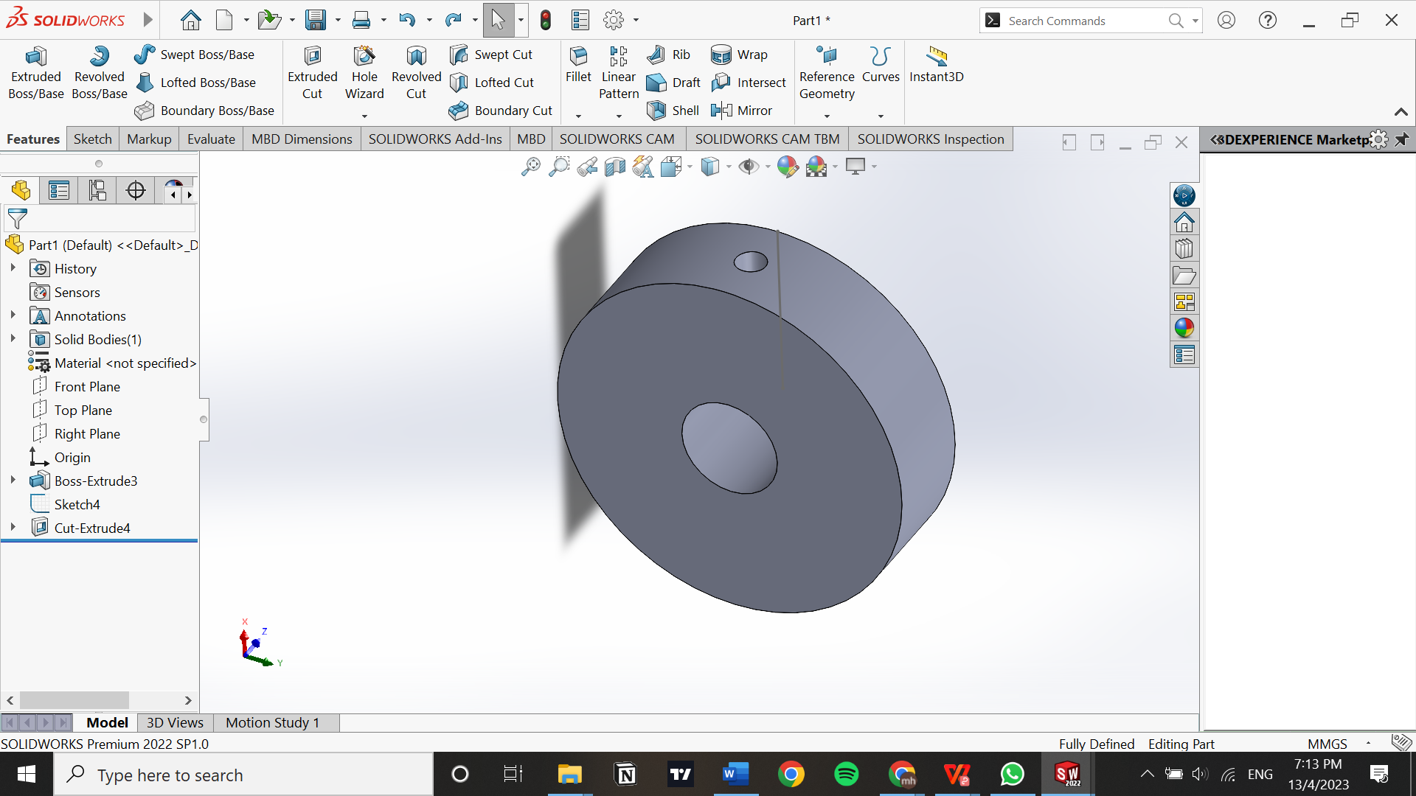

Figure 3.9 Design of coupling

Coupling is a circular plate with diameter of 35mm, shaft nominal diameter of 9.7 mm and radial hole diameter of 3mm.

3.5.5 Design of side board for motor



Figure 3.10 Design of motor side board

The dimension of side board for electric motor is 200mm of heigh, 120mm of width, and 5mm of thickness. The motor sideboard consists of 1 large hole with 17.6mm diameter and 2 small holes with 3.3mm diameter. The large hole is used for inserting drive shaft of the electric motor while small holes are used for inserting screws so that the electric motor can be fitted tightly on the sideboard.

3.5.6 Design of side board

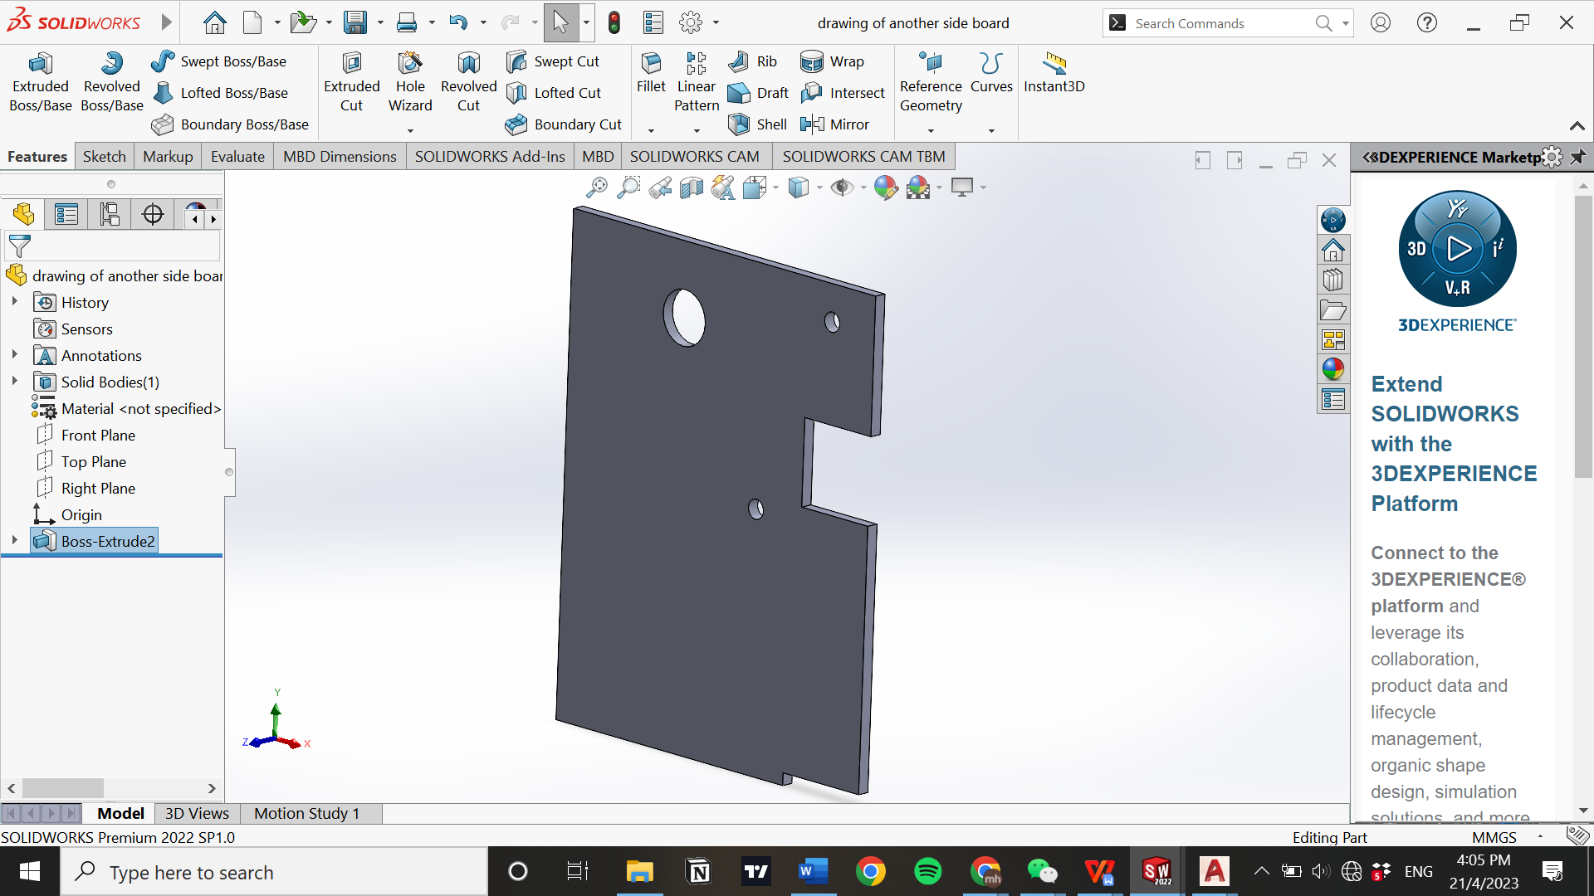

Figure 3.11 Design of another side board

The big hole is used for inserting bearing, so that the solid shaft can rotate smoothly. 2 smaller holes is used for inserting the bolt for the disc brake, so that the disc brake can be fitted tightly on the sideboard.

3.5.7 Design of syringe support

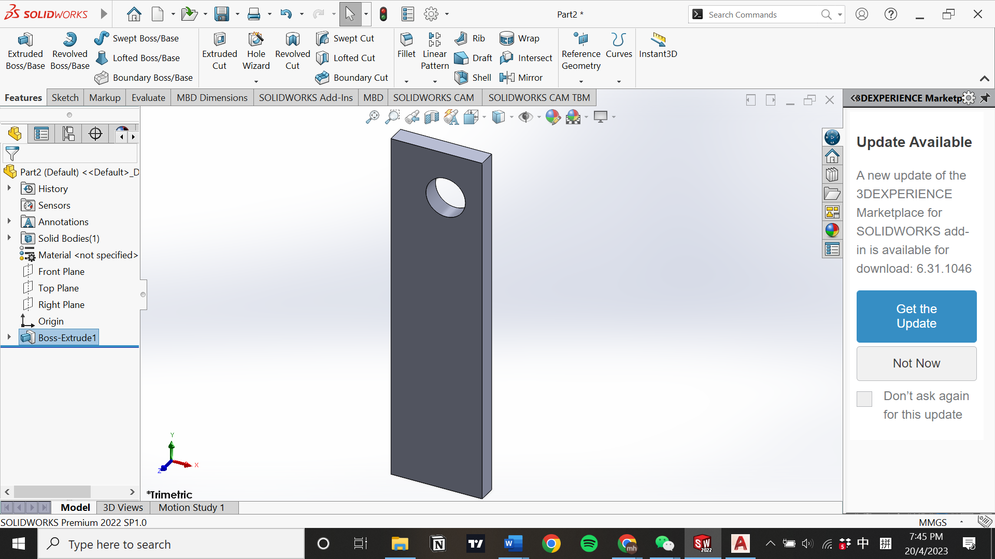

Figure 3.12 Design of syringe support

The dimension of the syringe support is 190mm of height, 50mm of width, and 10mm of thickness. Syringe support is used for support the syringe having generator on its end at appropriate height, so that the generator is able to engage with the brake gear during braking.

3.5.8 Design of bottom board

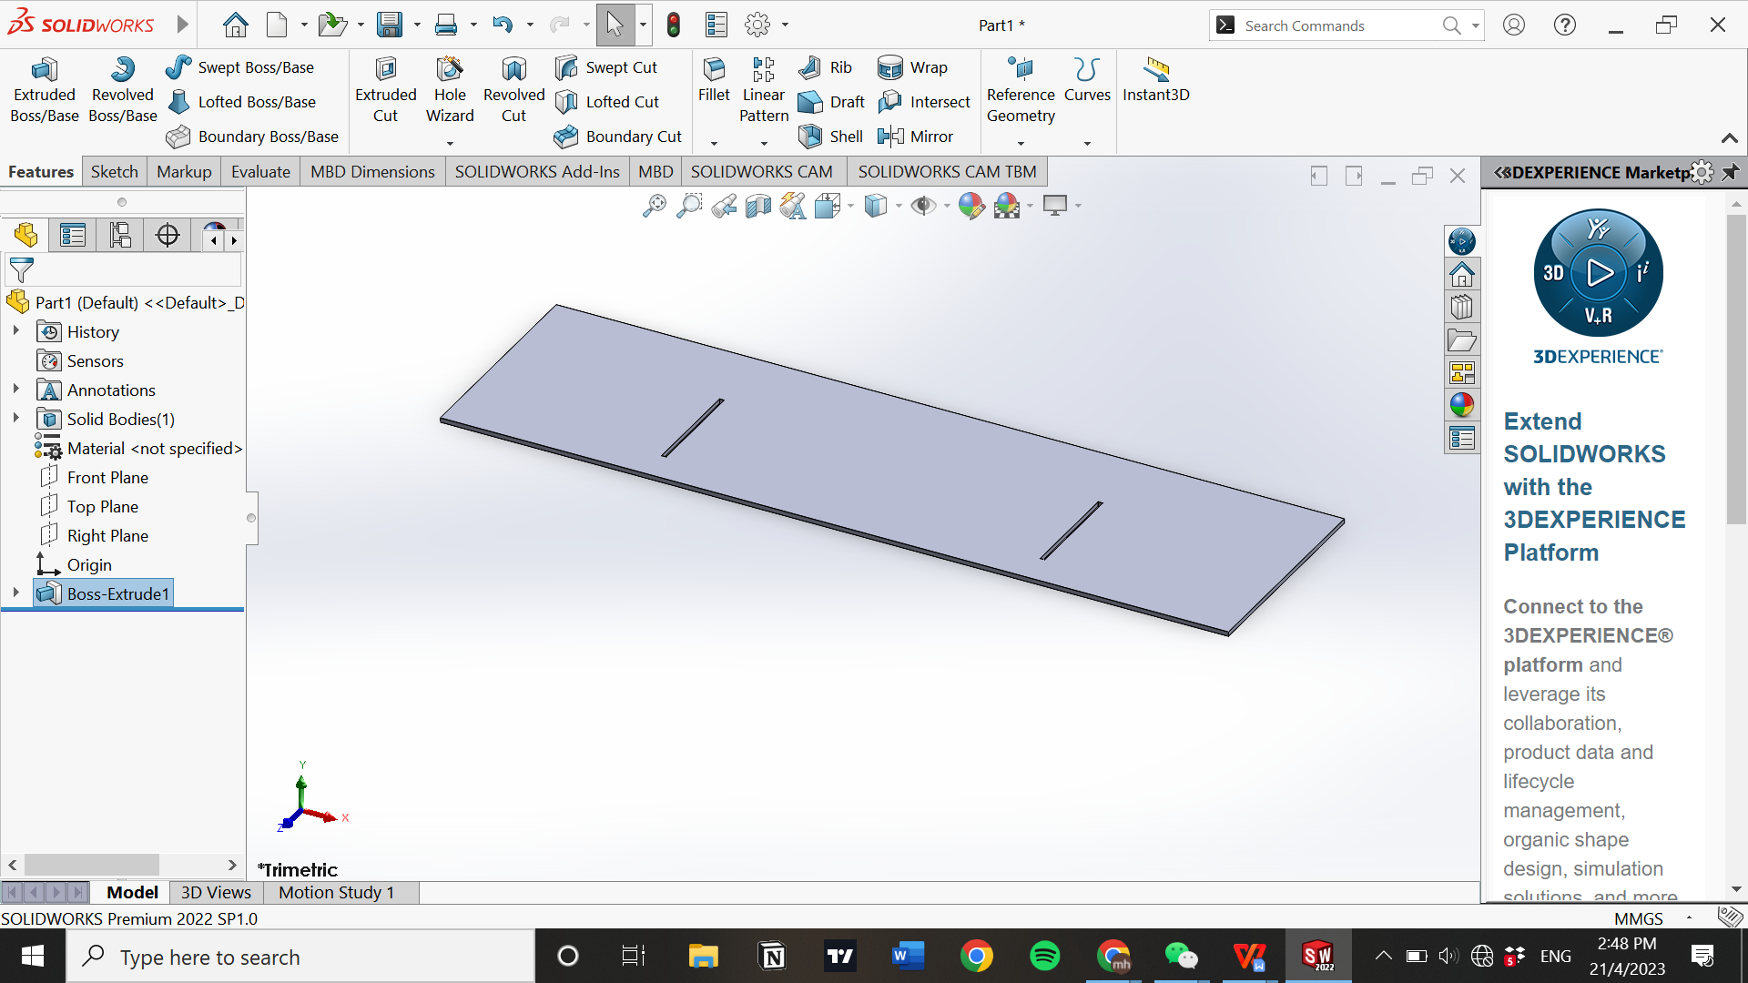

Figure 3.13 Design of bottom board

The bottom board consists of 2 rectangular slot which is used for inserting side boards.

3.5.9 Design of triangular support

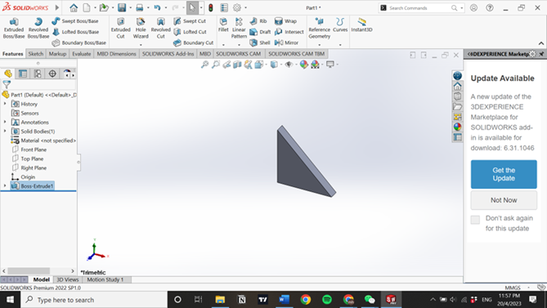

Figure 3.14 Design of triangular support

The dimension of triangular support is 30mm of height, 30mm of width, and 5mm of thickness. Triangular support is used to support the side board, prevent it from bending and ensure the side board form 90 degree with the bottom board.

3.5.10 Design of brake pedal assembly

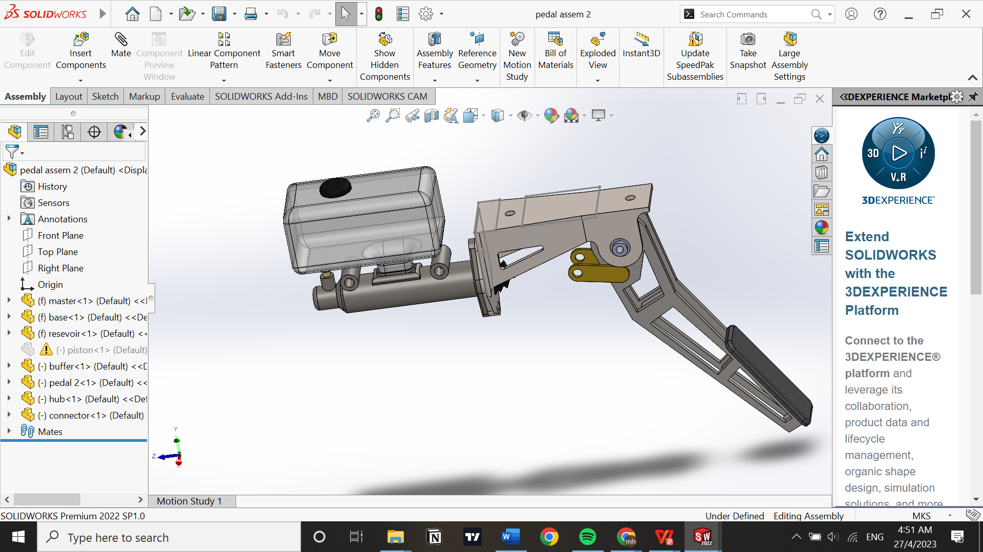

Figure 3.15 Design of brake pedal assembly

3.5.11 Design of disc brake

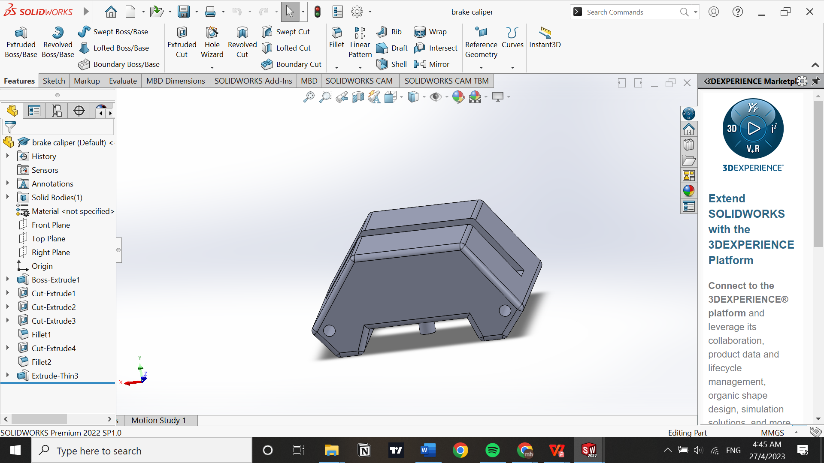

Figure 3.16 Design of disc brake

3.5.12 Design of syringe

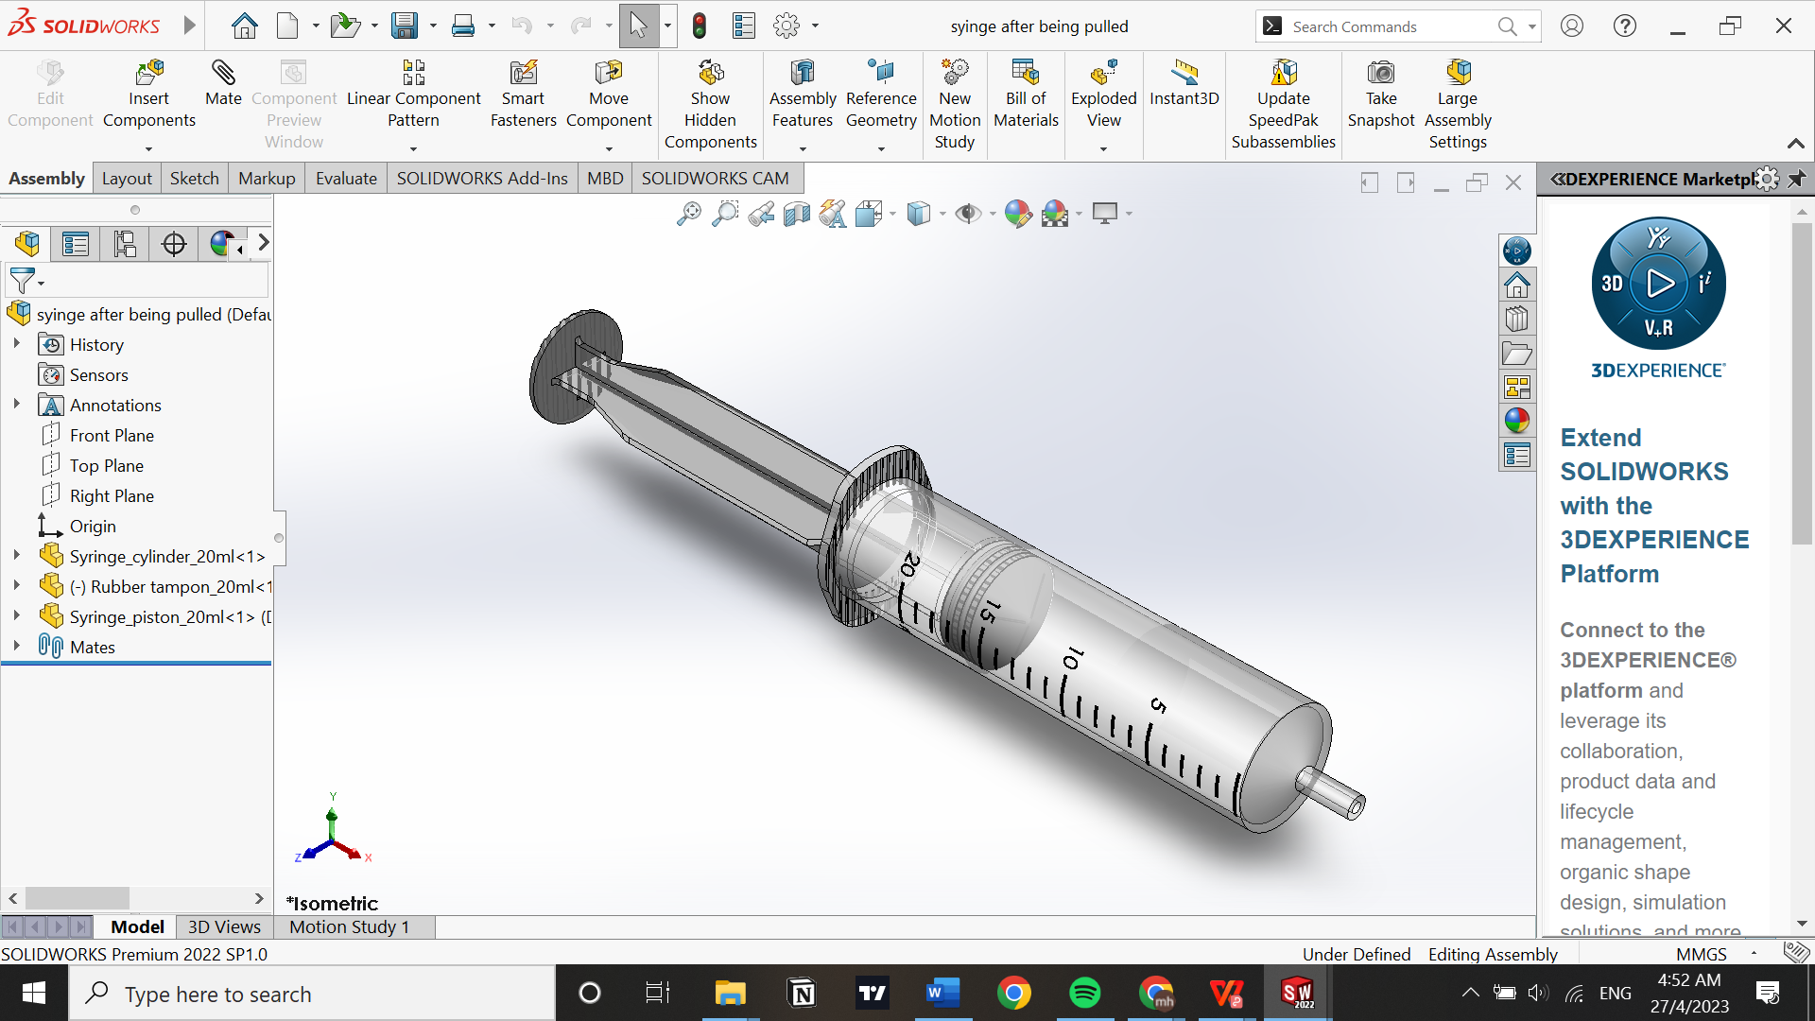

Figure 3.17 Design of syringe

3.5.13 Design of generator

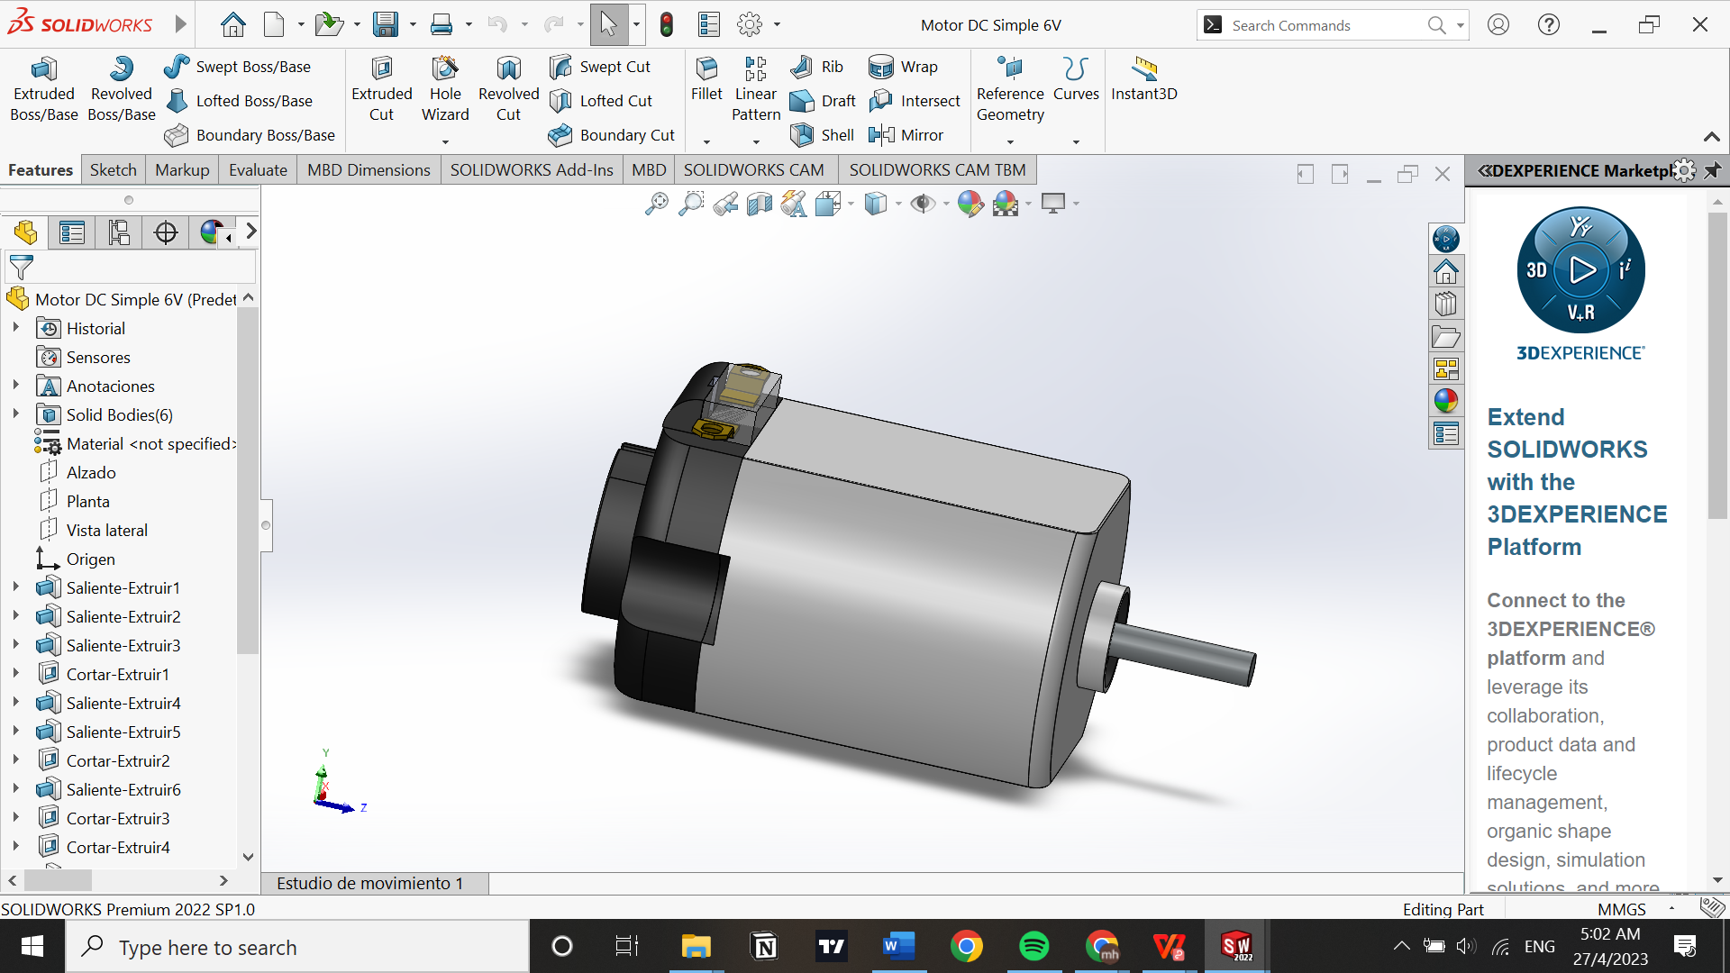

Figure 3.18 Design of generator

3.5.14 Design of electric motor

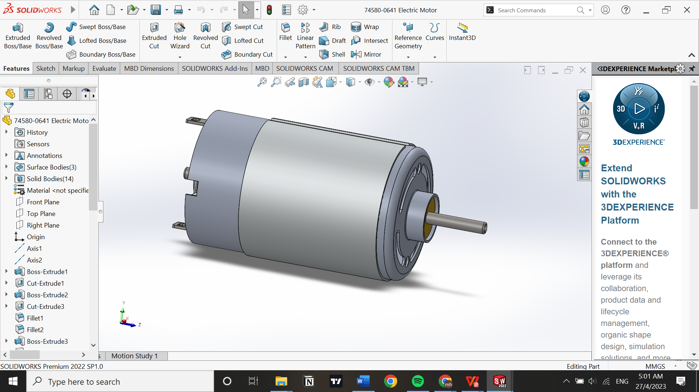

Figure 3.19 Design of electric motor

3.5.15 Design of rechargeable battery

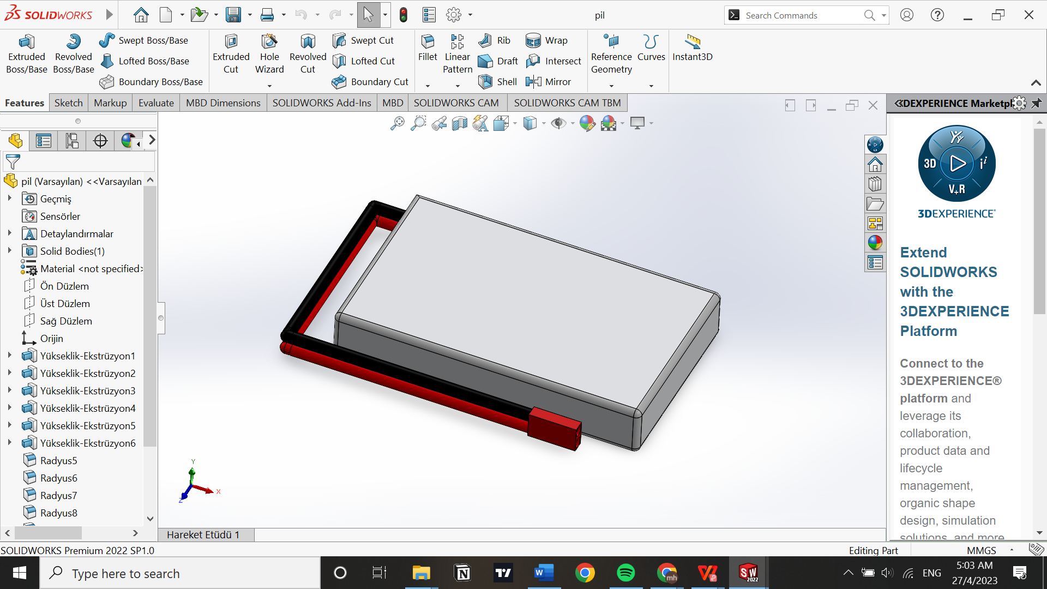

Figure 3.20 Design of rechargeable battery

3.5.16 Design of breadboard

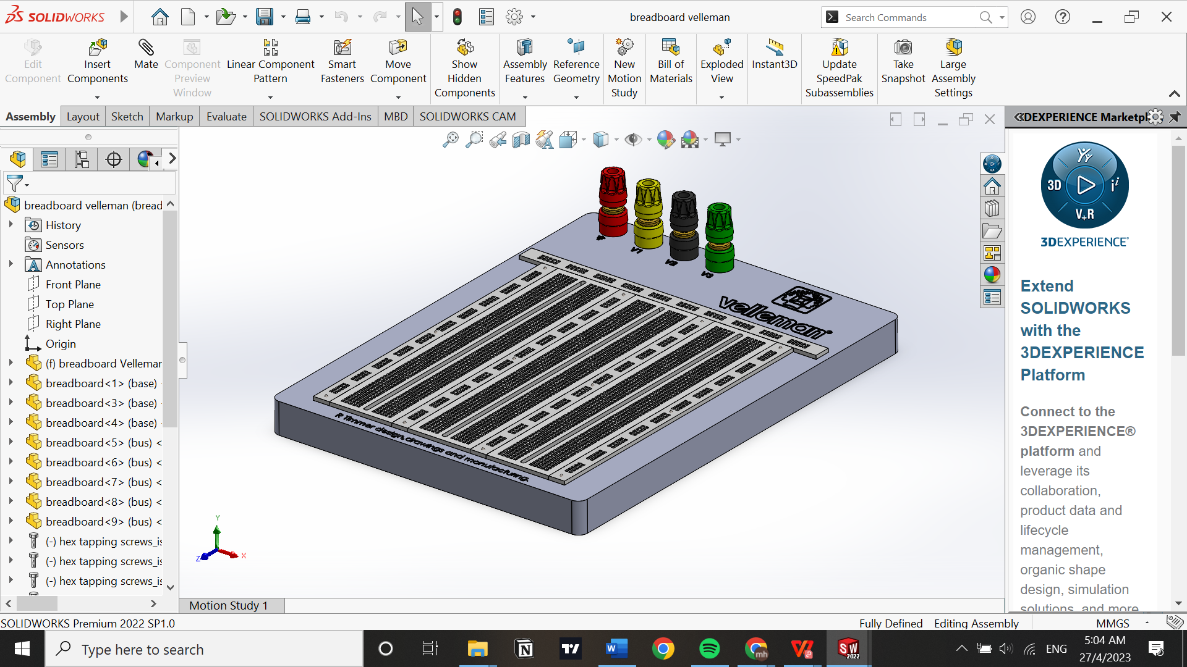

Figure 3.21 Design of breadboard

3.5.17 Circuit design of regenerative braking

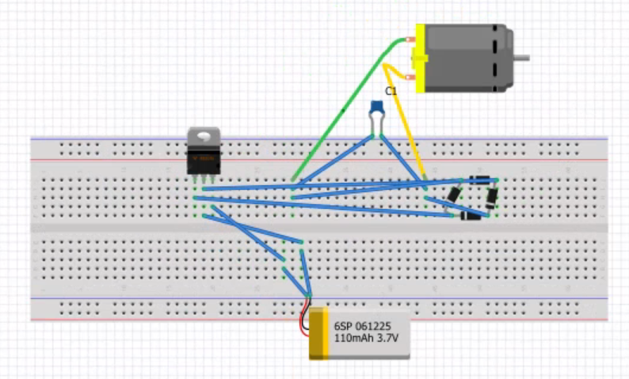

Figure 3.22 Regenerative braking circuit

The circuit consists of generator, capacitor, regulator, and bridge rectifier. The positive and negative terminal of the generator is connected to AC terminals of the bridge rectifier. The capacitor is connected to terminals of the generator. The negative terminal of the bridge rectifier is connected to the ground terminal of the regulator while the positive terminal of the bridge rectifier is connected to the input terminal of the regulator. The output terminal of the regulator is connected to the positive terminal of the battery while the ground terminal of the regulator is connected to the negative terminal of the battery.

When the generator is turned, The AC voltage generated passes through the rectifier and being converted into DC voltage. The DC voltage is then passed through the capacitor, the capacitor smoothens the DC voltage into a more stable voltage. Next, the stabilized DC voltage passes through the regulator. The regulator regulates the DC voltage into maximum of 5V to protect the battery. Finally, the DC voltage is fed into the battery.

3.6 Assembly drawing of prototype

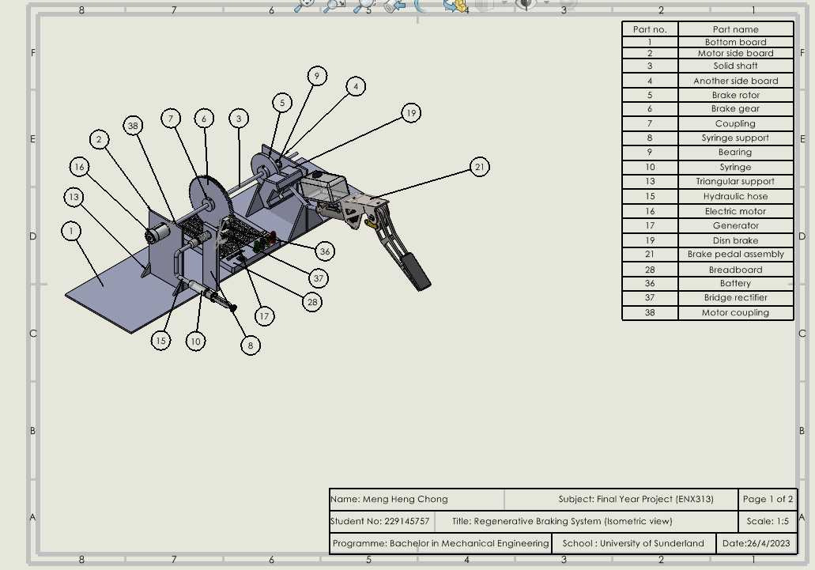

Figure 3.23 Isometric view of prototype

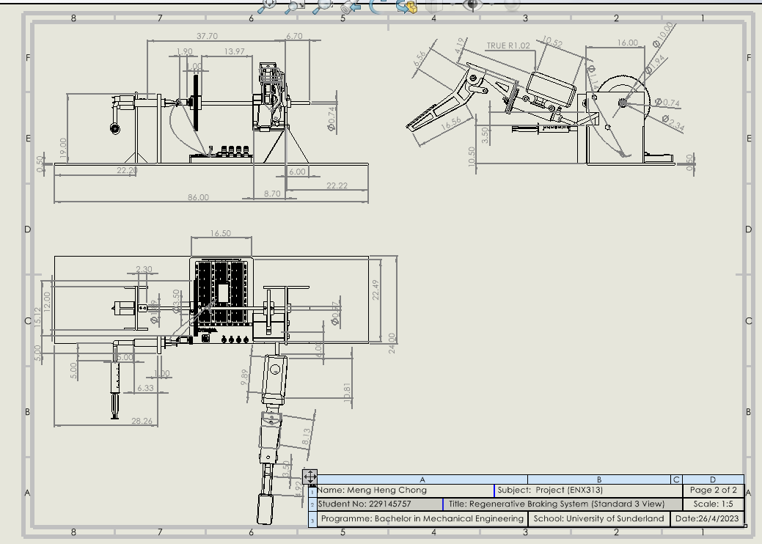

Figure 3.24 Standard 3 view of prototype

3.7 Equipment & tools used in fabrication of prototype

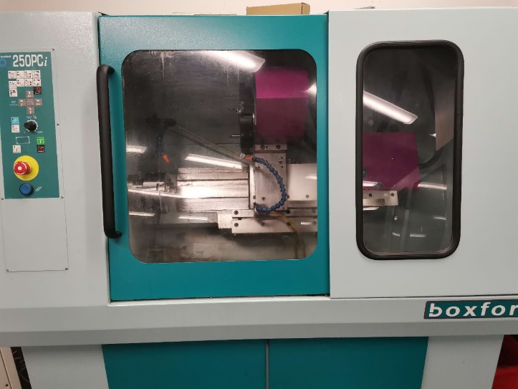

Figure 3.25 Lathe machine

Lathe machine is used in the fabrication of solid shaft. It is used to cut the solid shaft into required diameter.

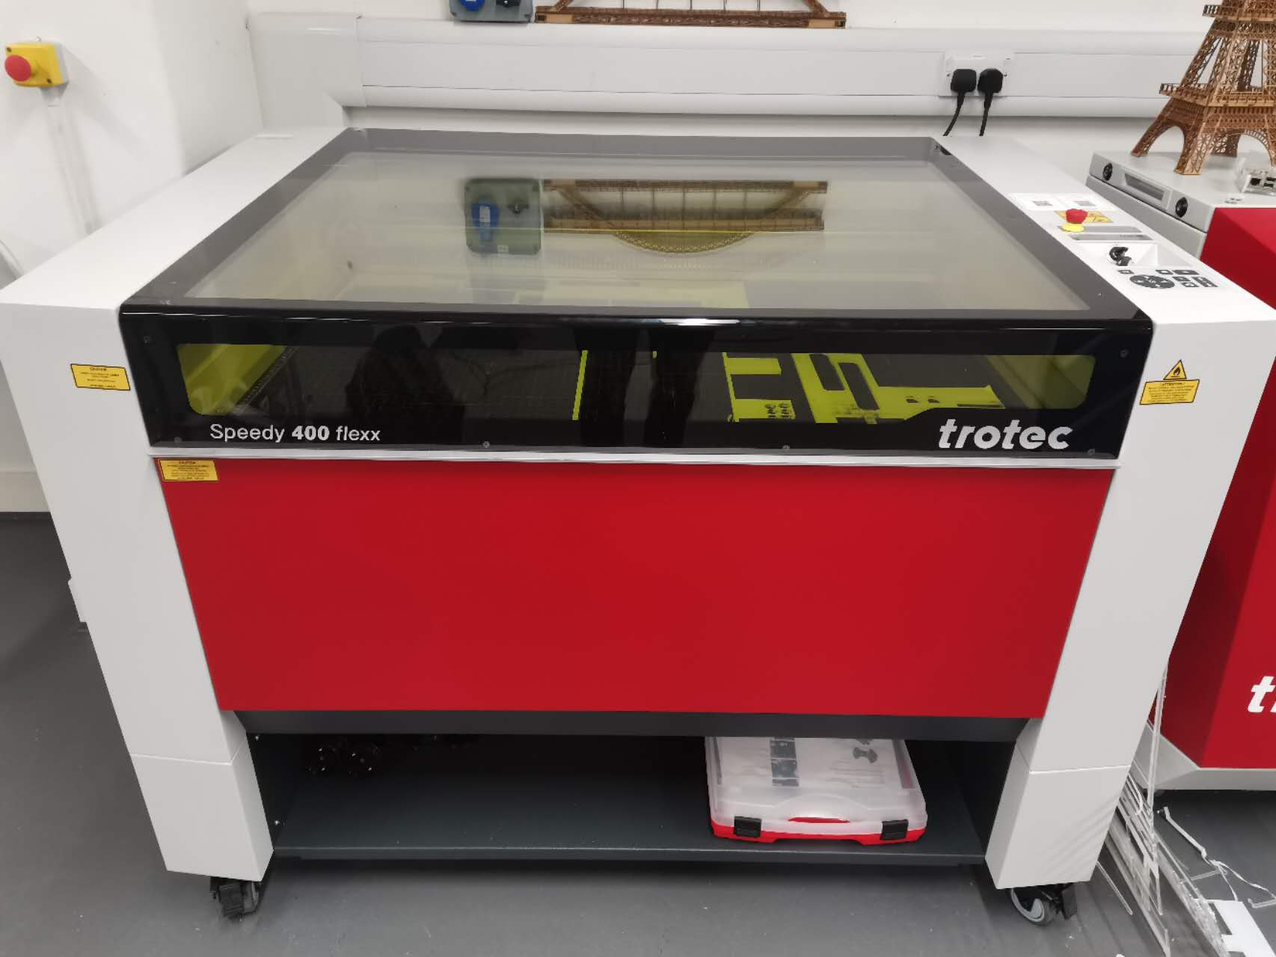

Figure 3.26 Laser cutting machine

During the fabrication of the prototype, laser cutting machine is used in the fabrication of brake gear, disc brake, coupling, bottom board, syringe support, sideboard and triangular support. After the design of components is completely sketched in Solidworks. The design is save as dxf.format and imported to a website called rubytech.com. After putting the board with a specific thickness into the laser cutting machine and adjusting the position of laser cutting through rubytech.com, the design is pushed to laser and the machine starts to cut the shape of the component.

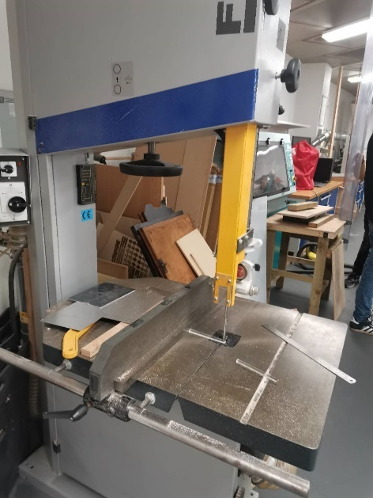

Figure 3.27 Bench cutting machine

Bench cutting machine is used in the fabrication of side board and rectangular support of the prototype. It is used for cutting the sideboard and rectangular support into the required length.

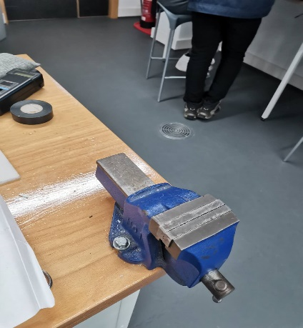

Figure 3.28 Workbench

Workbench is used to hold the parts during drill operation.

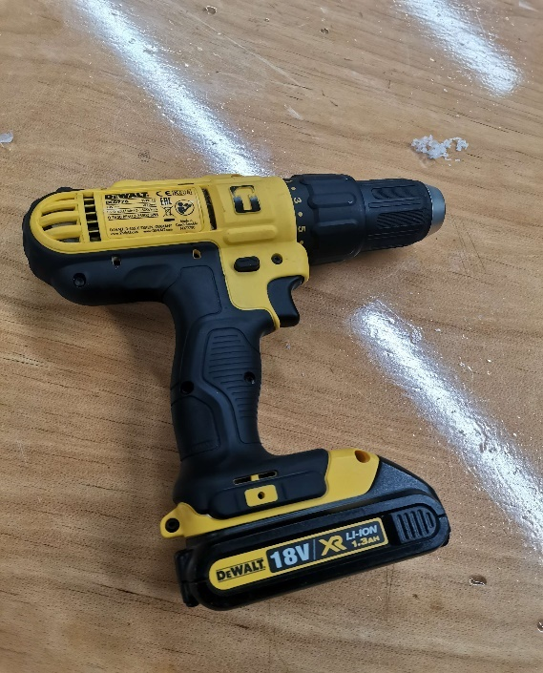

Figure 3.29 Drill

Drill is used in the fabrication of coupling. It is used to drill a hole on the radial surface of the coupling.

3.8 Fabrication of Component of regenerative braking system

3.8.1 Fabrication of solid shaft

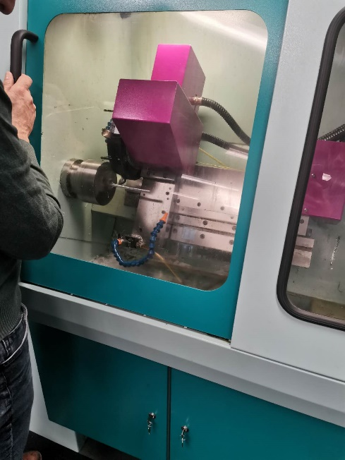

Figure 3.30 cutting solid shaft into required diameter using lathe machine

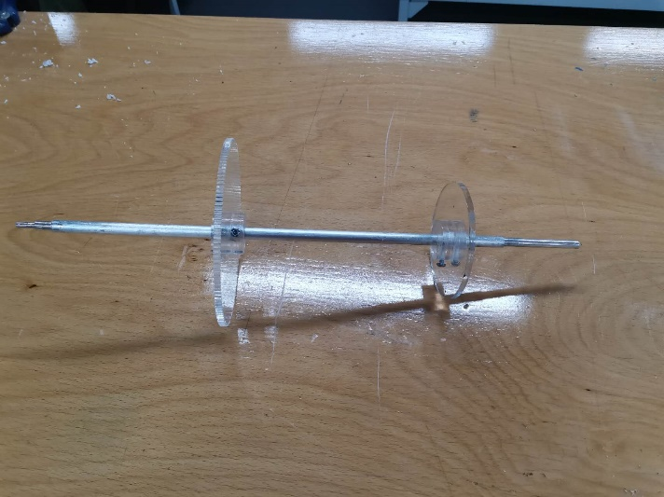

Figure 3.31 Complete solid shaft

Solid shaft is used to transfer the rotational motion of motor to the transmission system. When braking is occurred, shaft transfers rotational force from wheel to the electric generator. The brake gear, disc brake and bearing is fitted on the shaft. As shown in the figure below, the solid shaft is cut into designated diameter and geometry by using lathe machine.

3.8.2 Fabrication of brake rotor

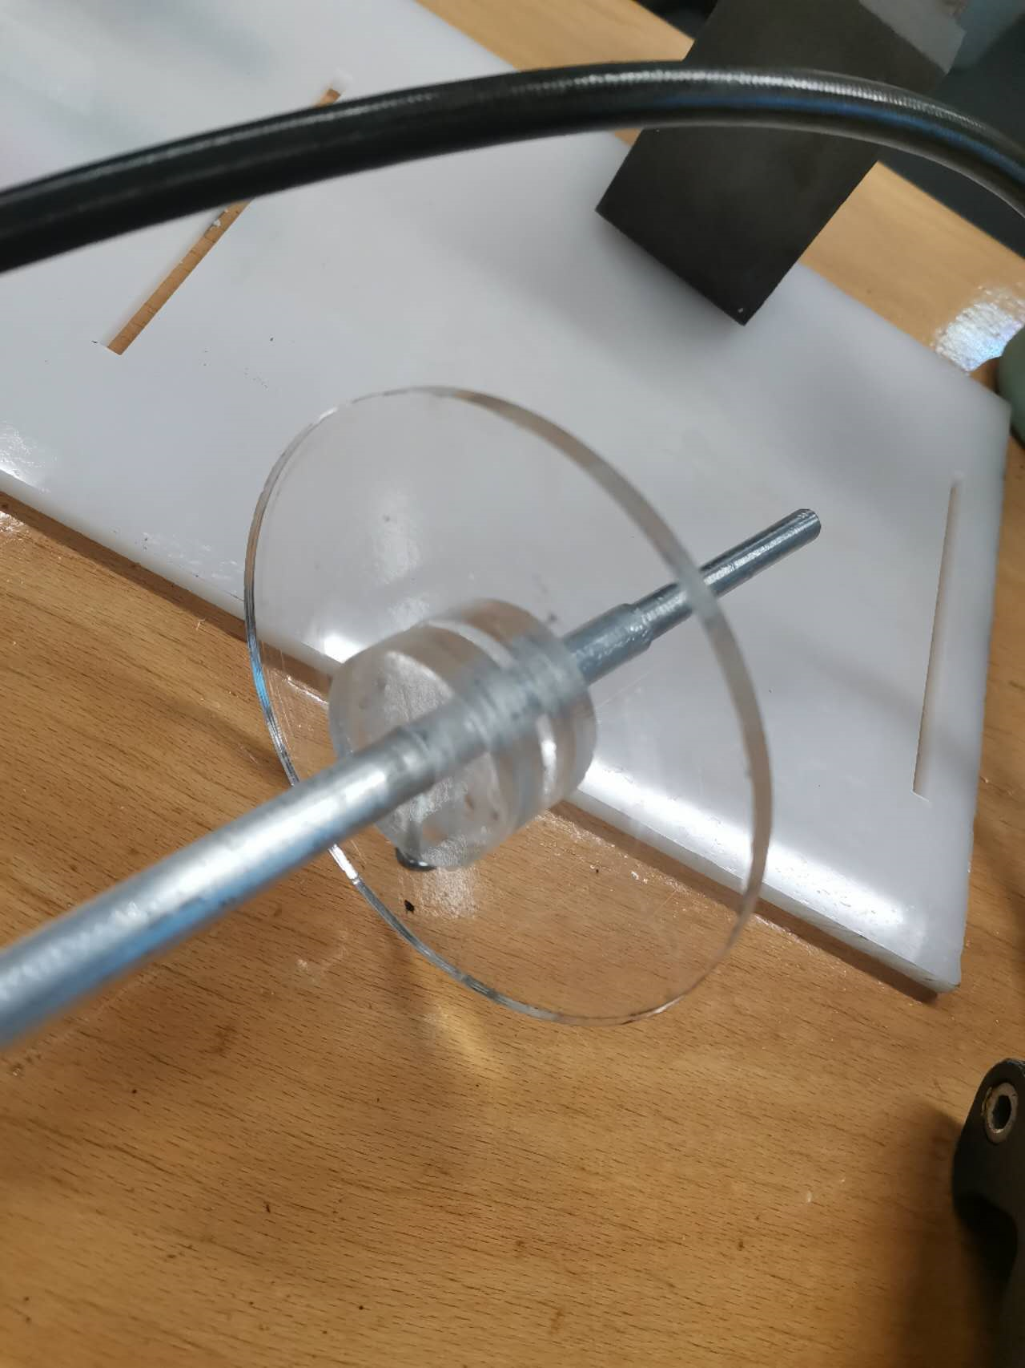

Figure 3.32 Fabricated disc brake

Brake rotor is used for braking purposes. When it is clamped by the brake pad, the rotor rotation is slowed down, thereby stopping the transmission system. After drawing the disc brake design in Solidworks, the drawing is saved as a dxf file and imported to the laser cutting machine. The disc brake is then cut in the laser cutting machine.

3.8.3 Fabrication of brake gear

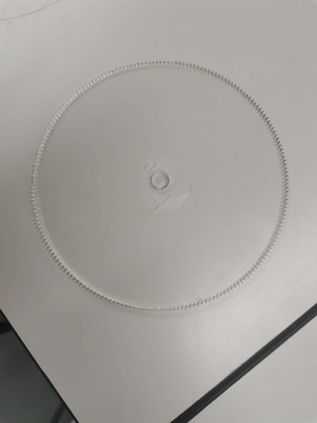

Figure 3.33 Fabricated brake gear

Brake gear is fitted on solid shaft used for regenerative braking purposes. When the brake gear with high rotation speed is engaged with the generator, the generator is turned and start generates electricity. After drawing the disc brake design in solidworks, the drawing is saved as dxf file and imported to the laser cutting machine. The brake gear is then cut in the laser cutting machine.

3.8.4 Fabrication of coupling

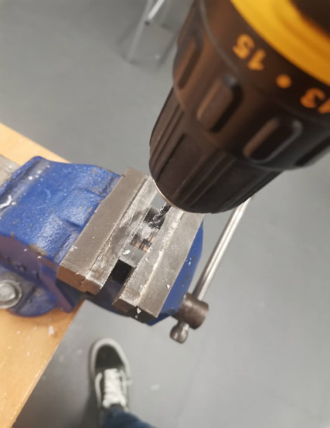 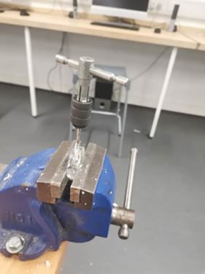

Figure3.34 Drilling on coupling Figure 3.35 Making thread on coupling

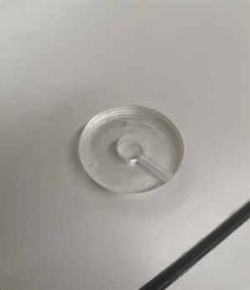

Figure 3.36 Coupling after production

Coupling ensures the component is fitted tightly on the shaft. Firstly, the shape of the coupling is cut using a laser cutting machine. After the coupling is cut, a hole is drilled on the radial of the coupling. The drilled hole is then threaded by using a tapper, so that screw can be inserted through the coupling. The completed coupling is stuck on the brake gear and the disc brake by using glue.

3.8.5 Fabrication of motor sideboard

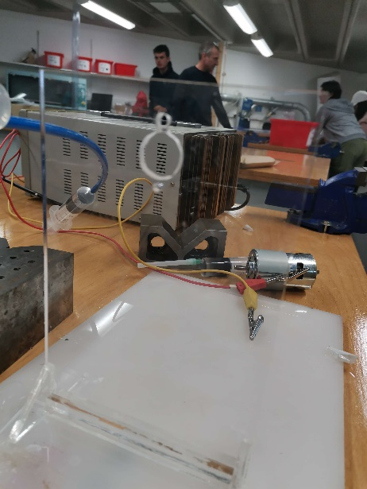

Figure 3.37 Complete motor sideboard

To fabricate motor sideboard, the dimension of the motor is measured fist to ensure it can be fitted on the motor sideboard. After designing in Solidworks, the motor sideboard is fabricated in the laser cutting machine.

3.8.6 Fabrication of side board



Figure 3.38 complete sideboard

To fabricate the sideboard, the geometry of the sideboard is designed and cut in a laser cutting machine. After finishing cut, the bearing is inserted into the hole to smoothen the rotation of the solid shaft.

3.8.7 Fabrication of syringe support

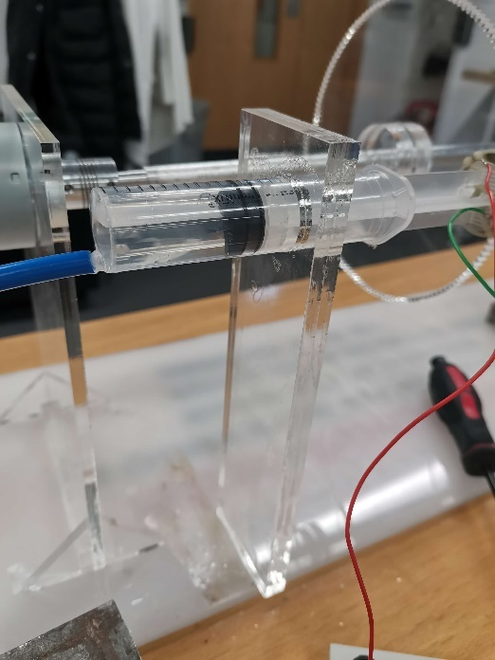

Figure 3.39 Complete syringe support

To fabricate syringe support, the dimension of the syringe is measured to ensure the syringe can be fitted on it. Next, the required heigh for generator to engage with the brake gear is measured to locate the hole of the syringe support. After designing in Solidworks, the syringe support is fabricated using laser cutting machine.

3.8.8 Disc brake

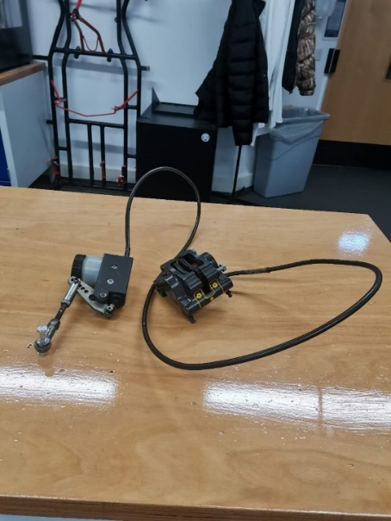

Figure 3.30 Hydraulic brake

Disc brake is used to clamp the brake rotor for immediate braking purposes. When the brake pedal is pressed, the brake pad clamps on the brake rotor and slow down the transmission system.

3.8.9 Motor coupling

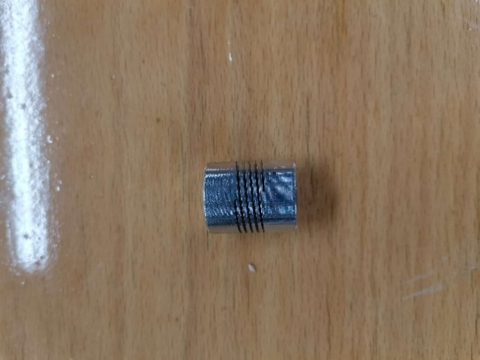

Figure 3.31 Motor coupling

Motor coupling is used to connect the electric motor with the solid shaft and transfer torque from the electric motor to the solid shaft.

3.8.10 Rechargeable battery

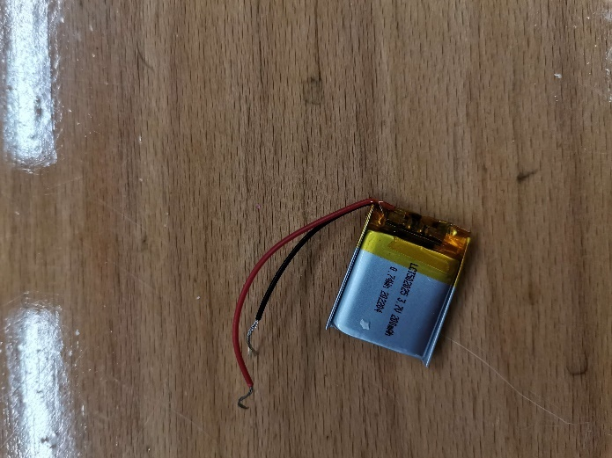

Figure 3.32 108mAh Lithium-Polymer battery

The battery acts as the energy storage unit the for regenerative braking system. When the regenerative brake is applied, the generator converts some of the kinetic energy into electrical energy. The electrical energy is then fed back into the battery for later use.

3.8.11 Generator

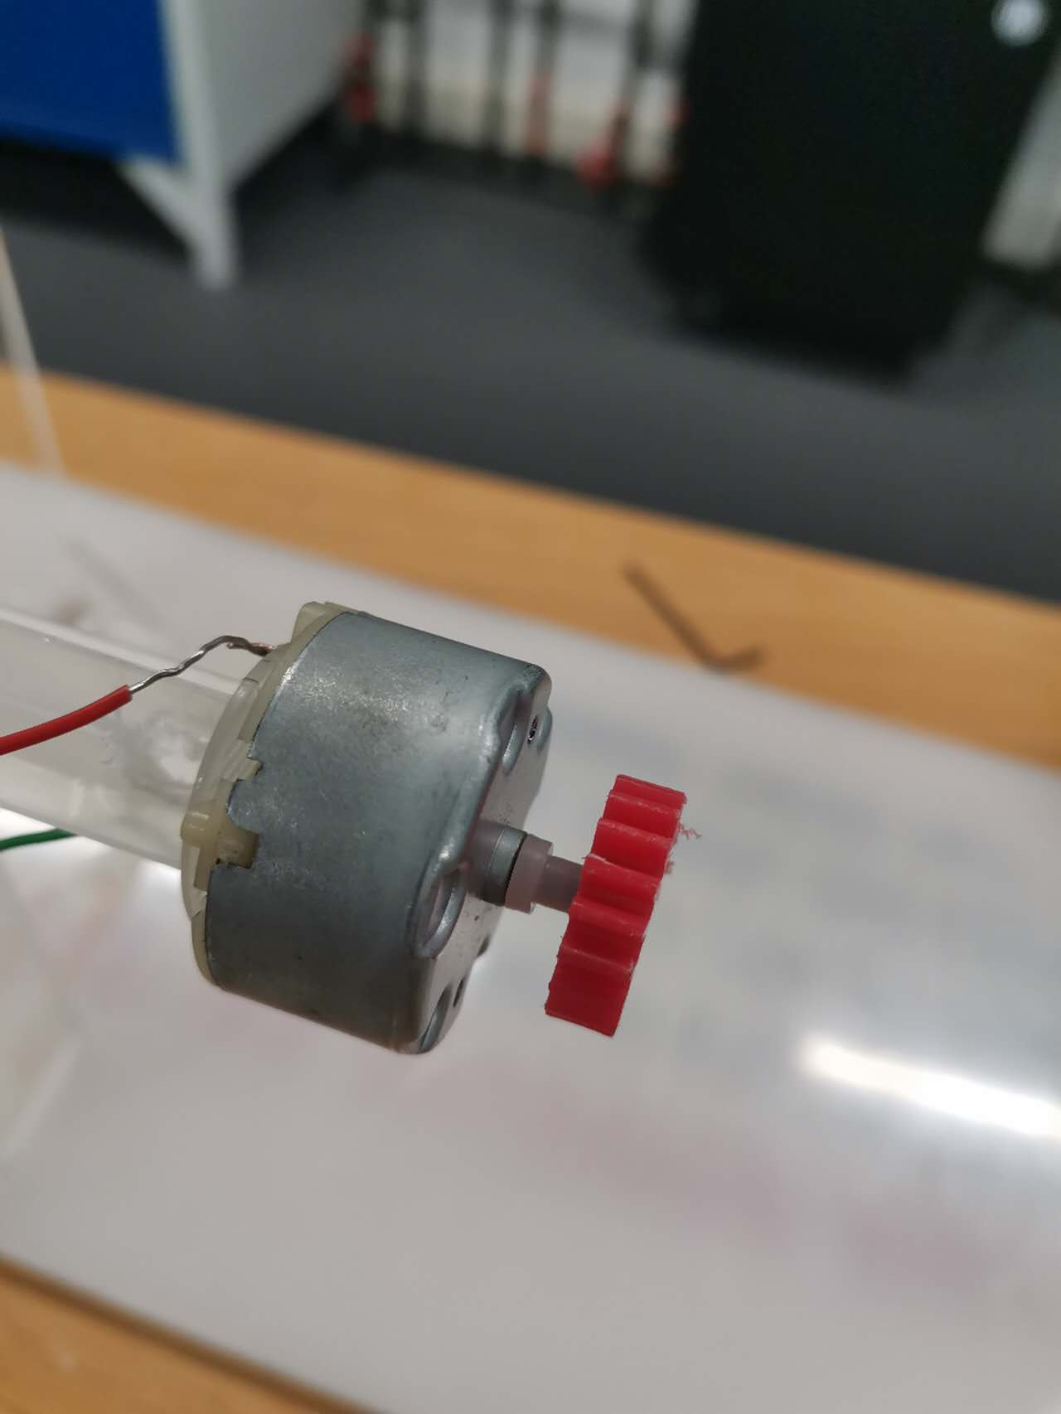

Figure 3.33 Electric generator

Generator is used to convert the kinetic energy of the rotating shaft into electrical energy. When the gear of the generator is engaged with the rotating brake gear, it starts to generate electricity, thereby slowing down the rotating shaft. It is fitted on the plunger of the syringe.

3.8.10 Syringe

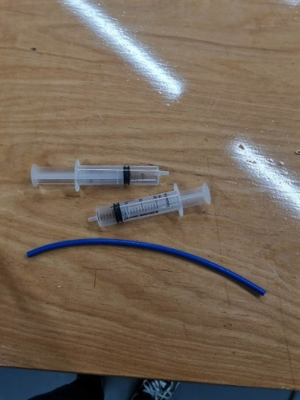

Figure 3.34 Syringe assembly

Syringes are connected using the hose. When the plunger of the syringe is pressed, the plunger of another syringe will move. It acts as the hydraulic system of the prototype, transferring the pressure from piston to piston through the hose.

3.9 List of parts Used In Fabrication

|  |  |  |  |
| --- | --- | --- | --- |
| No. | **Name of Part** | **Description** | **Quantity** |
| 1 | Solid shaft | 500mm with 9.7mm diameter | 1 |
| 2 | Electric motor | 12v DC motor | 1 |
| 3 | Brake rotor | 100mm diameter | 1 |
| 4 | Brake gear | 150 teeth with 1.0 modules | 1 |
| 5 | Generator | 6V Trumotion low inertia motor | 1 |
| 6 | Generator gear | 18 teeth with 1.0 modules | 1 |
| 7 | Hydraulic disc brake | Disc brake for go kart | 1 |
| 8 | Rechargeable Battery | 108mAh Lithium-Polymer battery | 1 |
| 9 | Bridge rectifier | - | 1 |
| 10 | Sideboard | 120mm x 200mm | 1 |
| 11 | Bottom board | 860mm x 240mm | 1 |
| 12 | Bearing | 22mm outer diameter x 7.8mm inner diameter | 1 |
| 13 | Coupling | 40mm outer diameter with 9.7 mm inner diameter | 4 |
| 14 | Motor sideboard | 160mm x 200mm | 1 |
| 15 | Motor coupling | - | 1 |
| 16 | Triangular support | 30mm x 30mm | 4 |
| 17 | Big triangular support | 100mm x 60mm | 4 |
| 18 | Breadboard | - | 1 |
| 19 | Regulator | 5V regulator |  |
| 20 | Bolt | M8 bolts | 2 |
| 21 | Capacitor | 25V capacitor | 1 |
| 22 | Screw | M3 screw | 4 |

3.10 Construction of the prototype

The construction of regenerative braking system can be categorized into the transmission and braking parts.

For the construction of the transmission system, the motor sideboard is fitted with motor using a screw and inserted into the slot of the bottom board. The motor sideboard is then fitted with rectangular support and triangular support using glue to increase its robustness. For another sideboard, the bearing is fitted on it using glue.

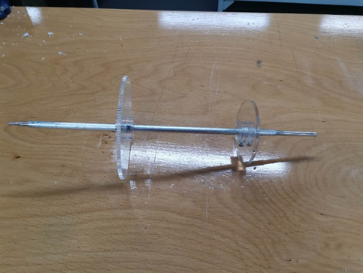

Figure 3.35 Solid shaft after assembled

For the assembly of solid shaft, the brake gear and brake rotor are fitted on the solid shaft using glue and coupling. After confirming the position of brake gear and brake rotor on the solid shaft. The screw is fitted into the coupling to ensure that the brake gear and brake rotor follows the rotation of the solid shaft.

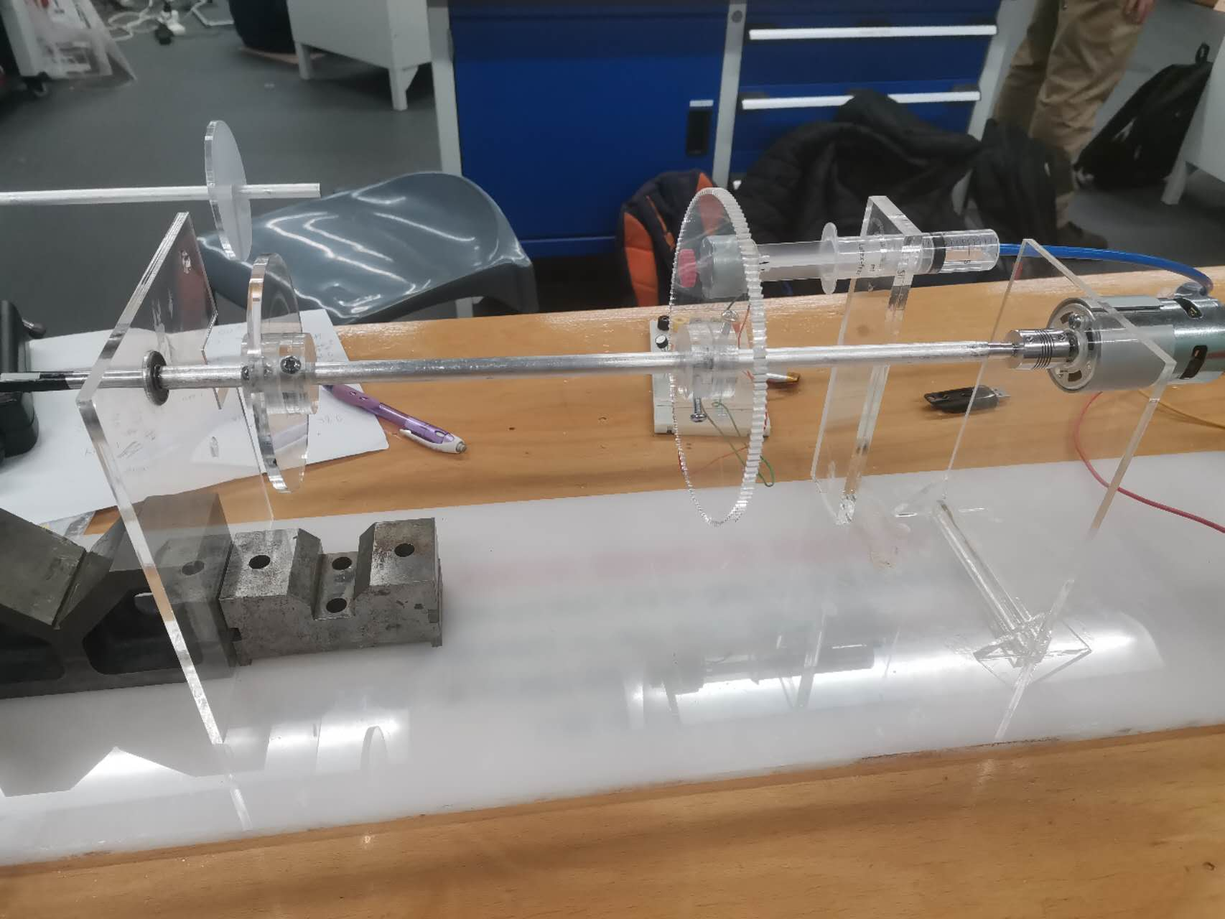

Figure 3.36 Transmission part of the prototype

To connect the motor with the solid shaft, one end of the motor coupling is fitted on the motor tip while the other end is fitted on the end of the solid shaft using Allen keys. The other end of the solid shaft is inserted to the sideboard. After the transmission system is built up, the sideboard is inserted into the slot of the bottom board and fitted with rectangular support and triangular support using glue to increase its robustness.

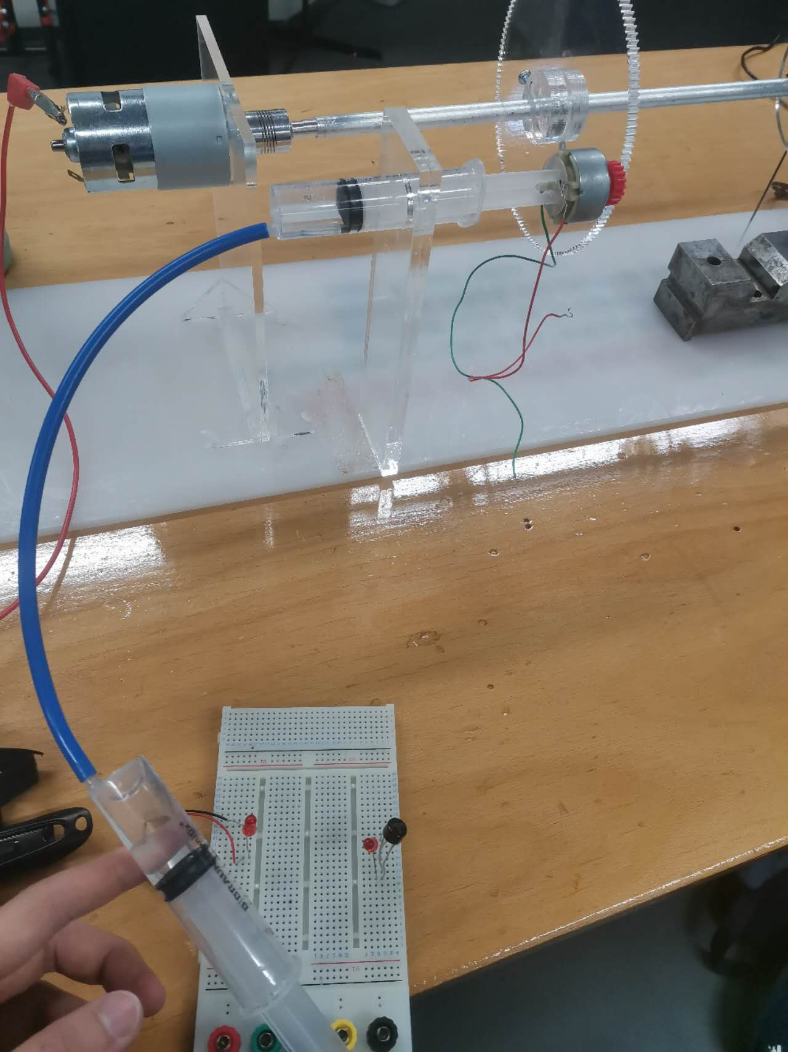

Figure 3.37 Regenerative braking part of prototype

The braking system can be categorized into conventional braking part and regenerative braking part. For the construction of regenerative braking, 2 syringes are connected through the hose. The plunger of the syringe is fitted with the generator using glue. The syringe support is fitted on the bottom board using glue. When pushing the plunge of the syringe, the syringe fitted with the generator will move towards the brake gear and engage with it.

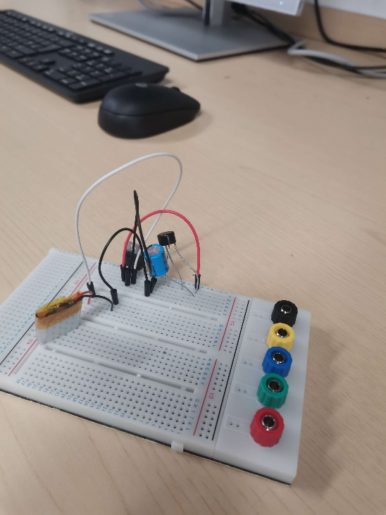

Figure 3.38 Complete circuit

The regenerative braking circuit consists of a battery, generator, bridge rectifier, capacitor, and regulator. The circuit is built according to the circuit design explain in Chapter 3.

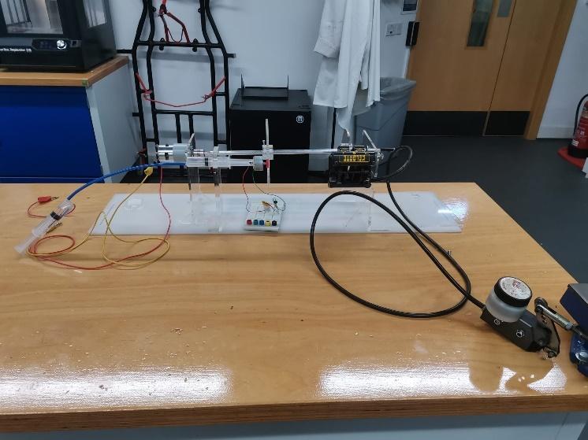

Figure 3.39 Complete construction of the prototype

For the construction of the conventional braking part, the brake rotor is inserted between the brake pads of the disc brake. The disc brake is then fitted on the sideboard using bolts. After all parts are fitted, the prototype is completed and ready to be tested.

3.11 Operation of prototype

To operate the prototype, the power supply is connected to the terminals of the motor through wires. The power supply is then turned on, and the electric motor starts to rotate depending on the current supplied. As the current increases, the speed of the motor increases. The regenerative brake is triggered and starts generating electricity when the generator engaged with the brake gear. This can be done by pushing the plunger of the syringe, and the generator will move toward the brake gear. The disc brake is used for the emergency brake. When there is necessary to stop the transmission immediately, the disc brake stops it when the brake pedal is pressed.

When the generator starts producing electricity, the AC voltage is generated. The AC is then passed through the rectifier and turns into DC voltage. The DC voltage is then pass through the capacitor; the capacitor is used to smoothen the flow of DC. The smooth DC is then passed through the regulator, the regulator regulates the DC into 5V to protect the battery. Finally, the DC is fed into the battery

3.12 Testing of the prototype

**Objective**

* To test the efficiency of the regenerative braking system at different motor speed.
* To test the braking performance of the regenerative braking system.
* To test the ability of regenerative braking system to store the electricity generated during regenerative braking.

**Apparatus**

* Tachometer
* Power supply
* Crocodile clip
* Multimeter
* Light reflecting sticker

**Procedure**

1. The electric motor is connected to the power supply through the crocodile clip.
2. A light reflecting sticker is stuck at the end of the solid shaft.
3. The voltage level of the battery is measured using a multimeter and recorded.
4. The motor speed is controlled to reach 100 rpm by adjusting the current supplied on the power supply.
5. Using a tachometer to determine whether the electric motor reaches the required rpm.
6. Once the electric motor reaches the required rpm, the gear of the generator is engaged with the rotating brake gear by pushing the plunger of the syringe.
7. The speed of the shaft after applying regenerative brake for 1 second is measured by using a tachometer and recorded.
8. The peak voltage generated during regenerative braking is measured by using multimeter and recorded.
9. The time taken to stop the shaft completely is measured by using a timer and recorded.
10. The procedure is repeated to test the efficiency of regenerative braking when the electric motors is rotating at 300rpm, 500rpm, 1000rpm, 1500rpm, and 2000rpm.
11. After the testing, the voltage level of the battery is measured and recorded.

Chapter 4 Results & Discussion

4.1 Results

|  |  |  |  |  |
| --- | --- | --- | --- | --- |
| Speed of motor | Time is taken to stop the shaft by regenerative braking | Speed of shaft after regenerative braking is applied for 1 second. | Speed of shaft after disc brake is applied for 1 second | Peak voltage generated (V) |
| 100rpm | 0.4s | 0 rpm | 0 rpm | 0.11V |
| 300rpm | 0.86s | 92.9 rpm | 0 rpm | 3.79V |
| 500 rpm | 1.21s | 150.1rpm | 0 rpm | 6.4V |
| 1000 rpm | 2.19s | 464.9 rpm | 0 rpm | 14.1V |
| 1500 rpm | 3.61s | 973.5rpm | 0 rpm | 19.61V |
| 2000 rpm | 4.66s | 1236rpm | 0 rpm | 24.6V |

Table 4.1 Testing result

|  |  |
| --- | --- |
| Voltage level of battery before testing | Voltage level of battery after testing |
| 3.04V | 3.52V |

Table 4.2 Voltage level of battery before and after testing

Graph 4.1 Time taken to stop the transmission system against speed of motor

Graph 4.2 Peak voltage generated during regenerative braking against speed of motor

From the result of testing, it is investigated that the higher the speed of the motor, the higher the peak voltage generated during generative braking. Besides that, it is also investigated that the higher the speed of the motor, the longer the time taken to stop the transmission system completely by applying regenerative braking. Furthermore, it is investigated that when the motor speed is at 100 rpm, the peak voltage generated during regenerative braking is very low (0.11V). The voltage level of the battery has increased from 3.04V to 3.52 V after the testing.

4.2 Discussion

The result of testing shows that the prototype is able to slow down the transmission system and generate electricity during regenerative braking. When braking the transmission system at 100rpm, the peak voltage generated by the regenerative brake is only 0.11 V. It is much lower than that of 300 rpm and 500rpm. Regenerative braking is less efficient at low speeds because the kinetic energy of the transmission system is relatively low, so there is less energy available to be recovered. Besides that, the frictional loss in the motor and generator possesses a high percentage of the total energy when the transmission system is at low speed, which in turn reduces the efficiency. Overall, the result shows that as the speed of the motor increases, the peak voltage generated by regenerative braking increases. Therefore, the peak voltage generated during regenerative braking is directly proportional to the speed of the motor.

Besides that, the result of testing shows that as the speed of the motor increases, the time taken for the regenerative brake to stop the transmission system increases. It is because the motor operating at high speed has more inertia stored in it, and it requires more energy to bring the transmission system to stop.

Furthermore, the testing found that the regenerative brake doesn’t stop the transmission system completely after applying for 1 second, except when the motor speed is 100 rpm. The regenerative braking system provides a smooth deceleration to the transmission system, which makes it takes more time to bring the transmission system to a complete stop. If there is necessary to stop the transmission system immediately, regenerative braking does not have enough braking power, and additional brake power is required from the disc brake. Therefore, the regenerative brake must be assisted by a disc brake for safety purposes, and it is a necessary backup if the regenerative brake fails.

As an addition, the speed of the shaft after the disc brake is applied for 1 second is always 0rpm. This is because the disc brake used in the prototype is actually the disc brake for a go-kart. When the pedal is pressed, the brake pad clamps on the brake rotor extremely tight.

The voltage level of the battery has increased slightly from 3.04V to 3.52V, which means the battery is charged during regenerative braking.

The limitation of the prototype is that it produces huge noise when the generator is engaged with the brake gear. The sound is not obvious when there is a low motor speed, but it is very noisy when there is a high motor speed. Besides that, there is friction occurred between the generator gear and the brake gear. To solve these issues, the gear is lubricated and the alignment is checked to reduce the damage to the gear.

Top of Form

Chapter 5 Conclusion & further work

5.1 Conclusion

In this project, the kinetic energy of the transmission system is harvested and converted into useful electrical energy through a regenerative brake. The main idea of this project is to utilize the kinetic energy of the transmission system to turn the generator. This is done by fitting brake gear on the solid shaft and gear on the generator. When the motor is running at high speed, the generator’s gear is engaged with the brake gear when braking is necessary and starts generating electricity. The electricity generated is fed into the rechargeable battery for later use. The research founds that regenerative braking is only suitable in the situation where the vehicle is gradually slowing down and stopping. It has insufficient braking power to stop the transmission immediately if there is a dangerous situation, thus conventional braking is still necessary for safety purposes. In this prototype, the regenerative braking system is assisted by conventional braking.

The testing of the prototype founds that the peak voltage generated during regenerative braking is directly proportional to the motor speed. Besides that, the testing shows that regenerative braking is less efficient at low speeds due to less energy available to be recovered and high frictional loss of the motor and generator. Furthermore, the experiment also found that as the motor speed increases, it takes a longer time to stop the transmission system completely. As an addition, the voltage level of the battery is increased after the testing, it shows that the battery is charged during regenerative braking

The first objective of the project is to develop a prototype of a regenerative braking system that is able to convert the kinetic energy of the transmission system to electrical energy during braking. From the testing, the prototype is able to generate AC voltage, depending on the speed of rotation of the transmission system. The higher the speed of transmission, the higher the peak voltage generated during regenerative braking. Therefore, the first objective is achieved.

The second objective of the project is to develop a prototype of a regenerative braking system that is able to reduce the speed of the transmission system when the brake is applied. From the testing, the rpm of the transmission system is reduced drastically after the brake gear engaged with the generator. Therefore, the second objective is achieved.

The third objective of the project is to develop a prototype of a regenerative braking system that is able to store electricity generated from the electric motor during braking operation. The voltage level of the battery has increased during regenerative braking. Therefore, the third objective is achieved.

The fourth objective of the project is to develop a prototype of a regenerative braking system that is safe in various driving situations. The research founds that regenerative braking is only suitable in the situation where the vehicle is slowing down gradually. It has insufficient brake power to stop the vehicle immediately. In this prototype, the regenerative brake is assisted by a disc brake in order to gain high brake power while improving energy efficiency. Therefore, the fourth objective is achieved.

5.2 Further work

To further develop this project, a braking control system can be researched and developed in the future. The braking control system is designed to be able to switch between regenerative braking and conventional braking, depending on the speed of the vehicle and how huge the force is applied to the brake pedal.

Besides that, the project can be improved by developing an integrated circuit for the energy storage unit which decides when the battery is charged and when the battery is discharged to power the motor.

Furthermore, the project can be improved by developing a motor controller which makes the electric motor to be able to switch between power mode during acceleration and generator mode during deceleration. If it is achieved, only one electric motor is needed in the regenerative braking system, rather than 2 motors. Thereby saving lots of purchasing costs.

# Chapter 6 Reference

PDF] REGENERATIVE BRAKING SYSTEMS (RBS): Semantic Scholar, 2021. *REGENERATIVE BRAKING SYSTEMS.* [Online]   
Available at: https://www.semanticscholar.org/paper/REGENERATIVE-BRAKING-SYSTEMS-(RBS)-Bhandari-Dubey/ae15b77d6ee876d03d89bbeeede46bd0f1fe3ca8  
[Accessed 3 4 2023].

AKEBONO BRAKE INDUSTRY CO., LTD., 2023. *Disc Brakes｜Brakes for Automobiles｜Product｜Products and Technologies.* [Online]   
Available at: https://www.akebono-brake.com/english/product_technology/product/automotive/disc/  
[Accessed 1 4 2023].

Blog CLR, 2019. *Spur gear calculation tips.* [Online]   
Available at: https://clr.es/blog/en/spur-gear-calculation-tips/  
[Accessed 13 4 2023].

CarBikeTech, 2020. *Regenerative Braking: What Is It & How Does It Work?.* [Online]   
Available at: https://carbiketech.com/regenerative-braking-working/  
[Accessed 22 2 2023].

ConnectUS, 2018. *6 Advantages and Disadvantages of Regenerative Braking System.* [Online]   
Available at: https://connectusfund.org/6-advantages-and-disadvantages-of-regenerative-braking-system#:~:text=List%20of%20the%20Pros%20of%20a%20Regenerative%20Braking,the%20wear%20and%20tear%20on%20the%20braking%20system.  
[Accessed 23 2 2023].

Dreamstime, 2019. *How A Lithium Ion Battery Works.* [Online]   
Available at: https://www.dreamstime.com/how-lithium-ion-battery-works-d-render-section-charging-discharging-ions-flow-anode-to-cathode-separated-liquid-image160748470  
[Accessed 24 2 2023].

Electrek, 2018. *Regenerative braking: how it works and is it worth it in small EVs?.* [Online]   
Available at: https://electrek.co/2018/04/24/regenerative-braking-how-it-works/  
[Accessed 22 2 2023].

Energy Education, 2022. *Regenerative braking.* [Online]   
Available at: https://energyeducation.ca/encyclopedia/Regenerative_braking#:~:text=In%201967%2C%20the%20American%20Motor,their%20Prius%20series%20hybrid%20cars.  
[Accessed 21 2 2023].

Explain that Stuff, 2022. *How do regenerative brakes work?.* [Online]   
Available at: https://www.explainthatstuff.com/how-regenerative-brakes-work.html#invent  
[Accessed 21 2 2023].

Handyman tips, 2020. *What Are the Different Types of Braking Systems?.* [Online]   
Available at: https://handymantips.org/types-braking-systems/  
[Accessed 22 2 2023].

HowStuffWorks, 2009. *How Regenerative Braking Works.* [Online]   
Available at: https://auto.howstuffworks.com/auto-parts/brakes/brake-types/regenerative-braking.htm#pt6  
[Accessed 22 2 2023].

Mechanical Farm, 2021. *REGENERATIVE BRAKING SYSTEM PROJECT REPORT.* [Online]   
Available at: https://www.mechanical-farm.com/regenerative-braking-system-project-report/#NEED_FOR_REGENERATIVE_BRAKING_SYSTEM  
[Accessed 21 2 2023].

Mechanical Farm, 2021. *WHAT ARE THE TYPES OF TYPES OF REGENERATIVE BRAKING SYSTEM ?.* [Online]   
Available at: https://www.mechanical-farm.com/ufaqs/types-of-regenerative-braking-system/  
[Accessed 1 4 2023].

OnAllCylinders, 2021. *What is Regenerative Braking & How Does it Charge an Electric Vehicle Battery?.* [Online]   
Available at: https://www.onallcylinders.com/2021/02/21/what-is-regenerative-braking-how-does-it-charge-an-electric-vehicle-battery/  
[Accessed 23 2 2023].

Treehugger, 2021. *How Does Regenerative Braking Work in an Electric Car?.* [Online]   
Available at: https://www.treehugger.com/how-does-regenerative-braking-work-in-an-electric-car-5187239  
[Accessed 21 2 2023].

Wikipedia, 2023. *Regenerative braking.* [Online]   
Available at: https://en.wikipedia.org/wiki/Regenerative_braking  
[Accessed 22 2 2023].

Wikipedia, 2023. *Regenerative braking.* [Online]   
Available at: https://en.wikipedia.org/wiki/Regenerative_braking  
[Accessed 1 4 2023].

Chapter 7 Appendix

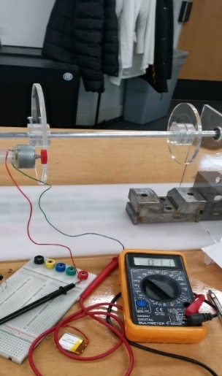

Figure 7.1 Testing result when the motor is running at 100 rpm

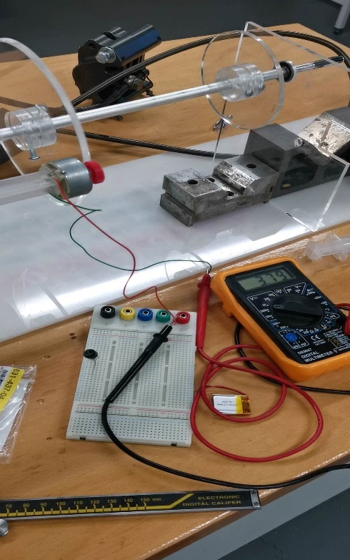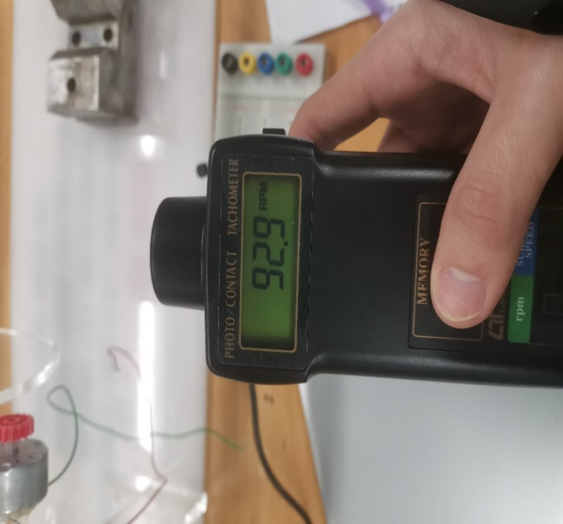

Figure 7.2 Testing result when the motor is running at 300 rpm

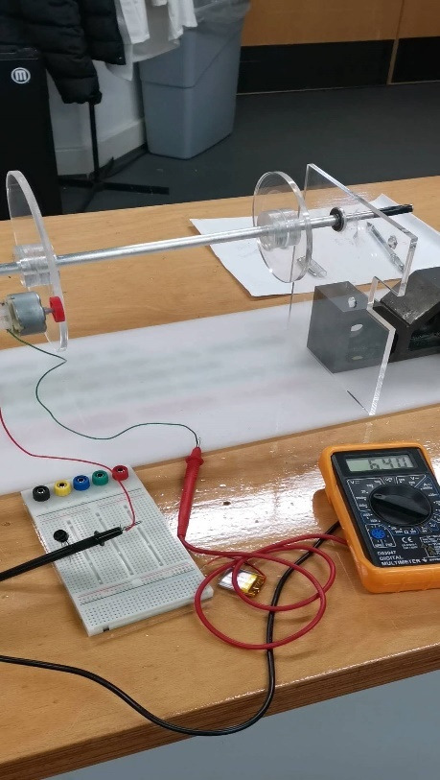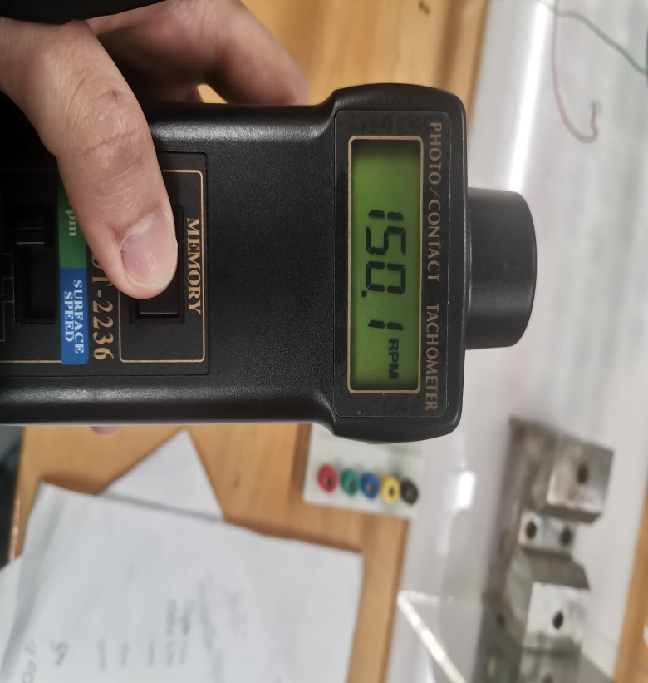

Figure 7.3 Testing result when motor is running at 500 rpm

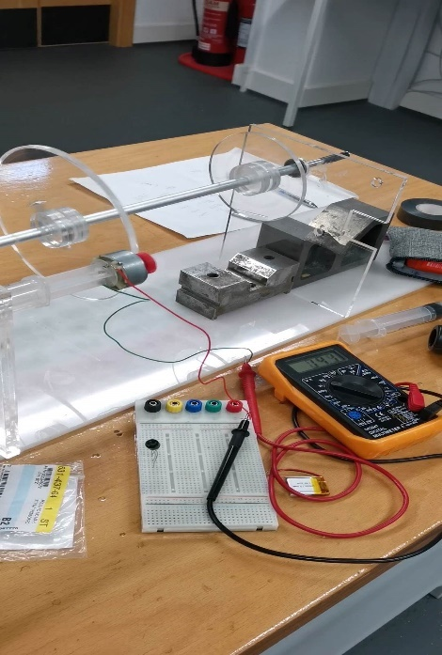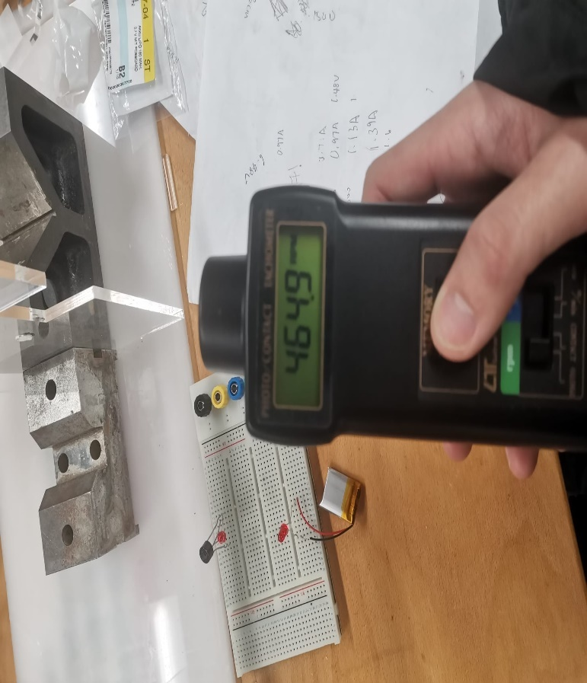

Figure 7.4 Testing result when motor is running at 1000rpm

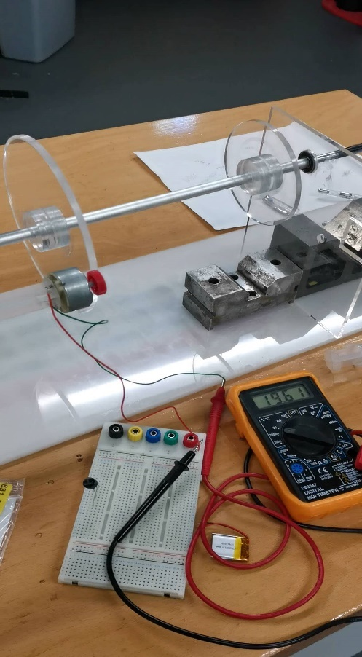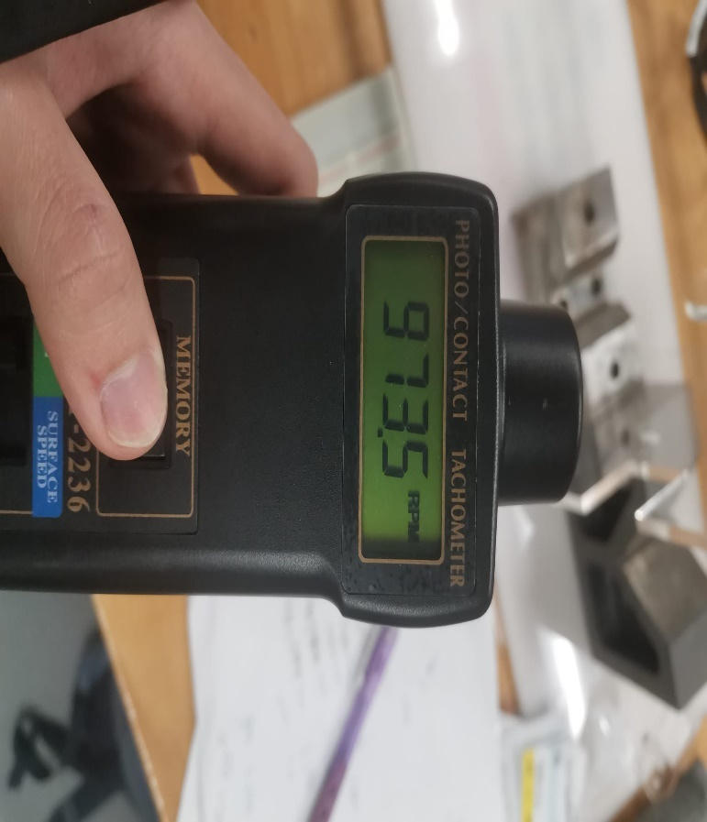

Figure 7.5 Testing result when motor is running at 1500rpm

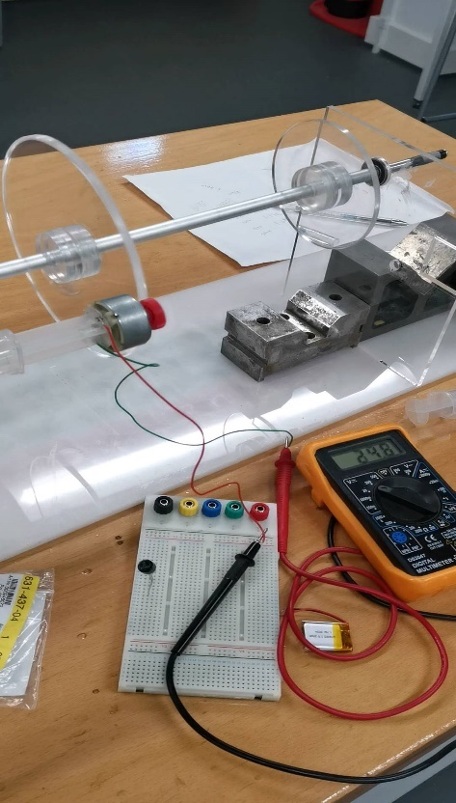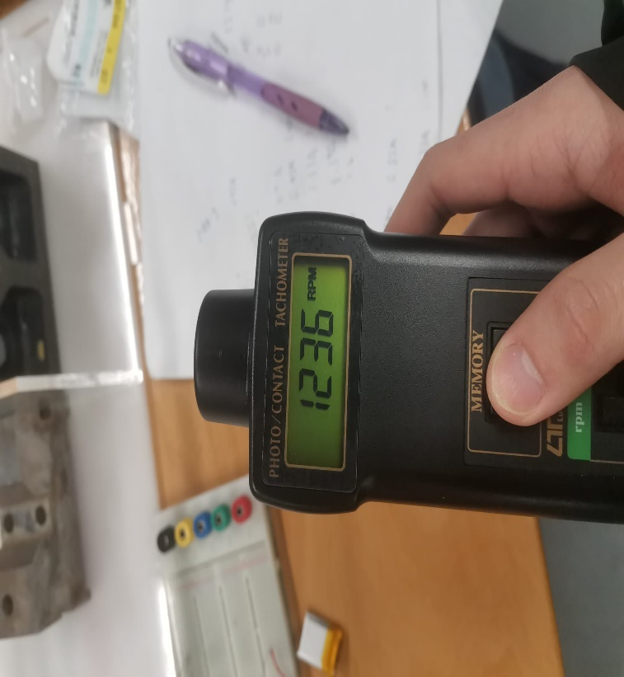

Figure 7.6 Testing result when motor is running at 2000rpm

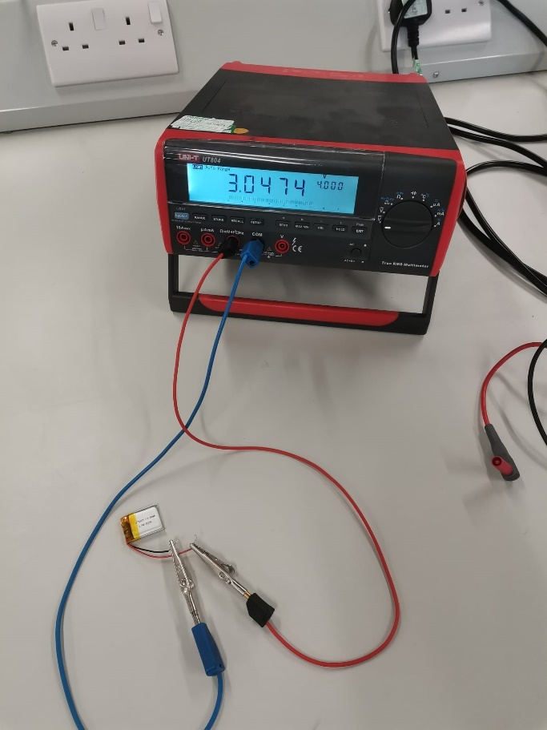

Figure 7.7 Voltage level of battery before testing

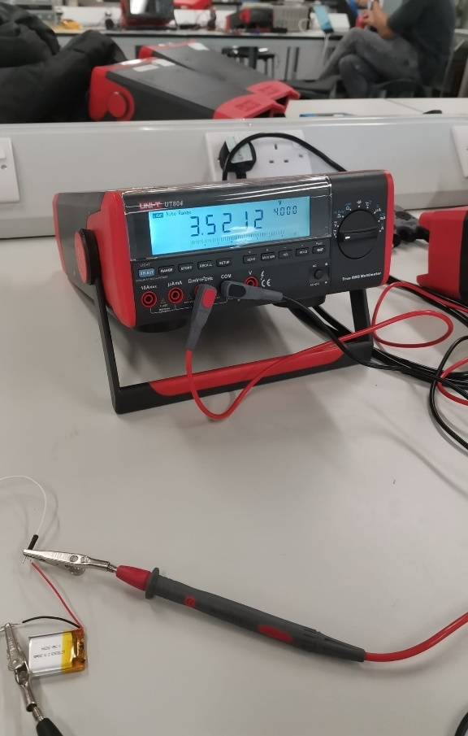

Figure 7.8 Voltage level of battery after testing